Start time and date: 4/15/2022 10:00AM

End time and date: 4/15/2022 10:00PM

Christopher Lall

CSc 342/343 – Professor Gertner

Take Home Test 1

Due 4/17/222



Table of Contents

Objective: 4

Part 1: MIPS 4

2-2_1.asm 5

Registers: 9

2-2_2.asm 10

2-3_1.asm 13

2-3_2.asm: 17

2-5_2.asm: 21

2-6_1.asm: 24

While-Loop: 27

For Loop: 31

If-Then-Else: 35

Section 2.8: Write a simple “MAIN” in MIPS assembly that calls “myadd” function and analyze 39

Part 2: Intel x32 ISA in Microsoft Visual Studio 42

2-2_1.c 42

2-2_2.c 46

2-3_1.c 48

2-3_2.c 51

2-5_1.c 54

2-6_1.c 57

Natural_generator.c 61

While.c 63

For.c 66

Myadd.c 67

Part 3: Intel x86_64 ISA, Linux 64bit (GDB) 68

2-2_1.c 69

2-2_2.c 72

2-3_1 73

2-3_2.c 74

2-5_1.c 75

2-6_1.c 76

Natural_generator.c 77

Myadd.c 78

For.c 79

If.c 80

While.c 80

Comparison: 80

Mips: 80

Intel x32: 82

Linux: 82

Conclusion: 83

# Objective:

The goal of this test is for students to demonstrate their understanding and ability to compare MIPS instruction set architecture, Intel x86 ISA using Windows MS 32-bit compiler and debugger, and an Intel X86 64 bit ISA processor running Linux with 64-bit gcc and gdb. Aside from that, this test uses the environment described above to assess students' grasp of the differences between local, static, and local static variables. We'll also look at how big endian and tiny endian are used in these two quite different settings.

# Part 1: MIPS

The following pictures below for Part 1 will consist of the actual MIPS code and its disassembly, memory, and registers. I will thoroughly explain how each of the code MIPS code work individually, however I will go over the parts of a disassembly, memory, and registers windows using 2-2_1.asm as an example.

## 2-2_1.asm

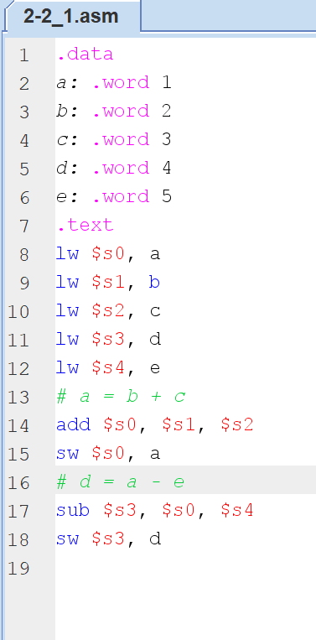

Figure 1. 2-2_1.asm file

Assembly in MARS MIPS is divided down into sections, which include .data and .text.

The Data Segment is where data is stored in memory (allocated in RAM), similar to variables in higher-level languages.

The Text Segment contains instructions and program logic

The .data section of MIPS is where static variables are declared. Static variables are data that the assembler allocates and whose size remains constant as the program runs. Its contents change; "static" refers to the fact that the size in bytes does not vary throughout operation.

Local variables are declared in the function. After exiting that function, all local variables will be removed. Local variables, unlike static variables, do not require long-term storage, hence they are not specified in the .data section.

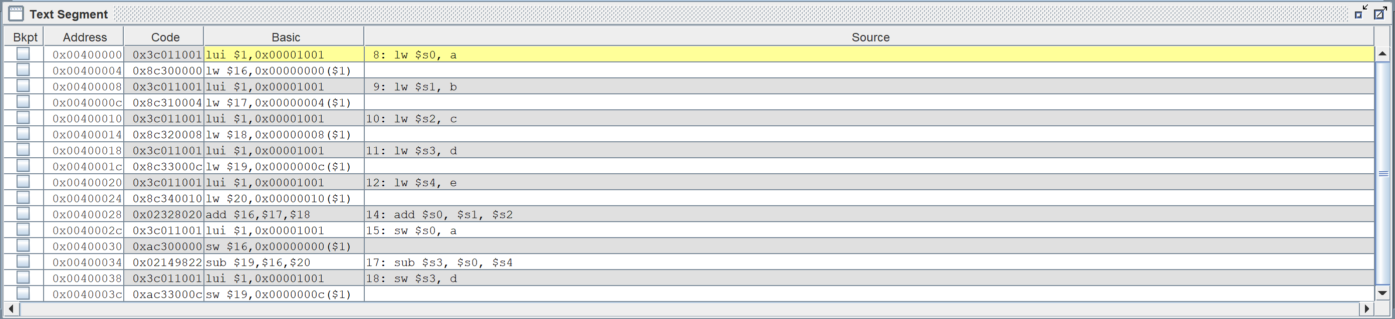A local static variable is a special variable in which it is only initialized once no matter how many time the functions is called. It only lives within the scope of the function in which it is declared, but its lifetime begins when the function is called and ends only when the program is terminated.

Figure 2. MARS Simulator of disassembly window.

Bkpt – Stands for breakpoint. Indicates if a breakpoint is set at this address

Basic - Assembly language version (using core MIPS instruction set) of the instruction

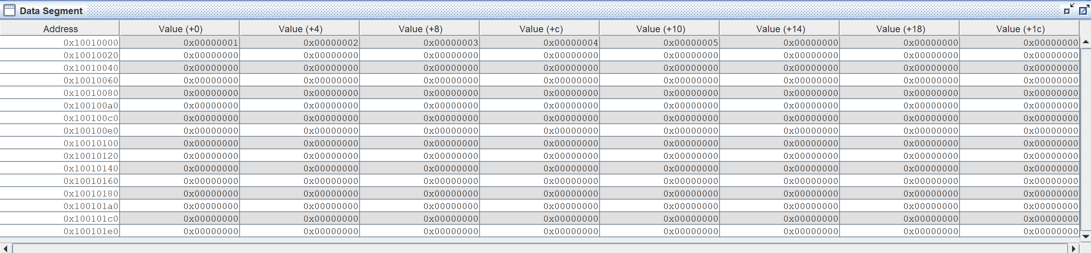Source: Actual source from your file (may differ from the Basic instruction if source contains pseudo-instructions)

Figure 3. Memory Window Mars simulator

The first column in the memory pane provides the address that is used as a reference. The value of the address corresponding to the value inside the parenthesis is represented by the rest of the column, which is labeled value. The value of address 0x10010000 + 4 is shown in the column labeled "Value (+4)" or the one boxed in orange. In other words, the address 0x10010004 has the value 0x00000002.

Endian is the method of storing multiple-byte data in computers, such as short, int, long, float, and double. Data in MIPS is stored in a format known as "Big Endian." This signifies that the data's initial byte is saved first.

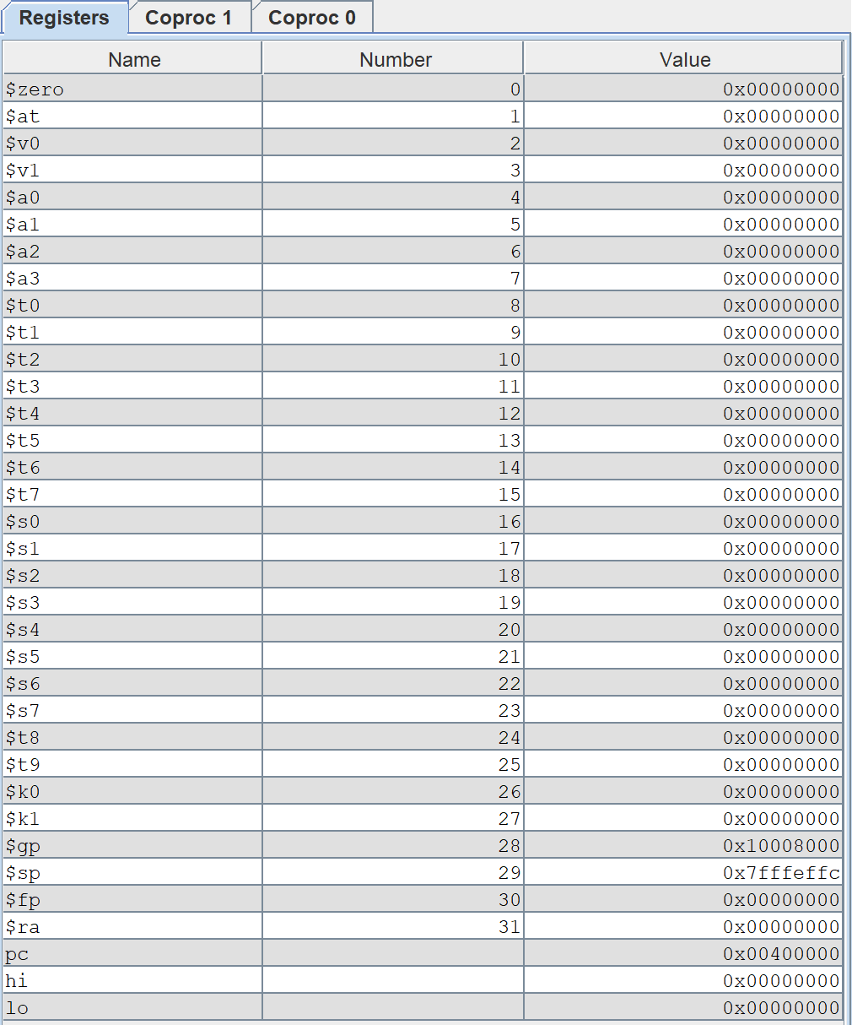

Figure 4. Register Window in Mars Simulator

The picture on right is the registers window. I will go over every register.

### Registers:

$zero : Zero register always hold the constant 0.

$at : Assembler temporary register reserved for assembler.

$v0 - $v1 : Return registers for returning values to caller function.

$a0 - $a3 : Argument registers for passing in arguments for subroutines.

$t0 - $t9 : Temporary registers used for intermediate calculations inside subroutines.

$s0 - $s7 : Saved registers where values are saved across subroutine calls.

$k0 - $k1 : Reserved for use by operating system and assembler.

$gp : Global pointer points to area in memory that saves global variables.

$sp : Stack Pointer which points to the last location in use on the stack.

$fp : Frame Pointer which points to the top of the stack.

$ra : Return address which is used by function call.

pc : Program counter which points to the next instruction to be executed.

hi, lo: They are not numbered registers, but they store the reuslts of operations that would not fit in a single register

## 2-2_2.asm

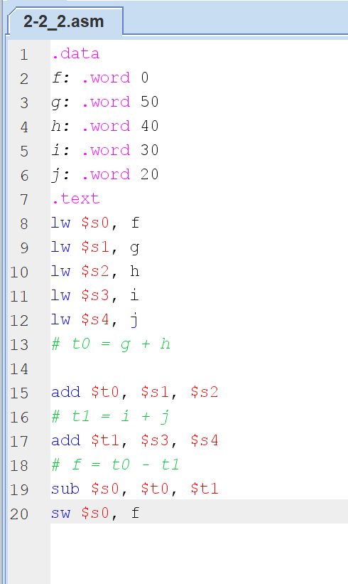

Figure 5. 2-2_2.asm code in Mars

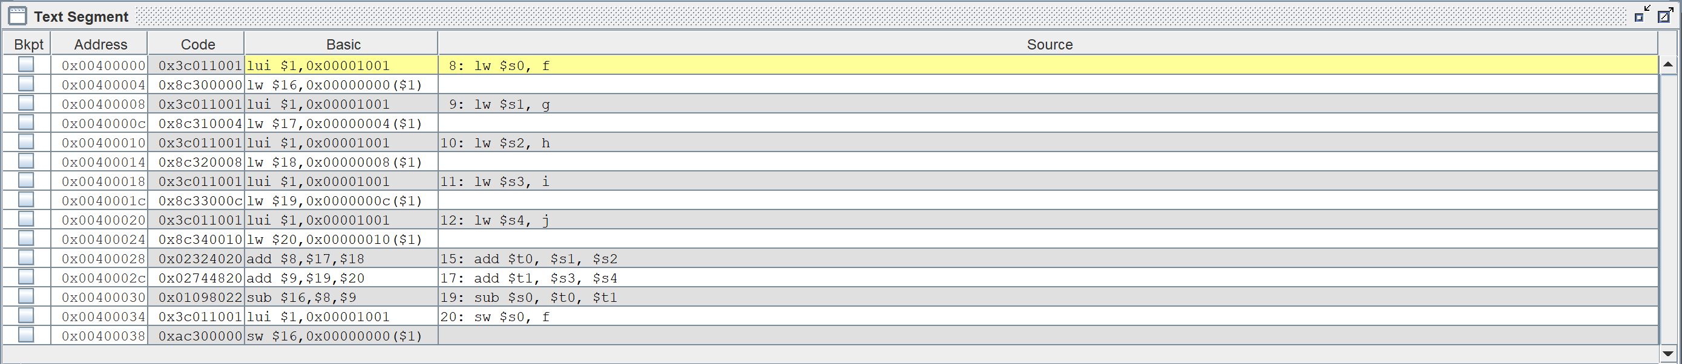

Figure 6. Text segment for 2-2_2.asm

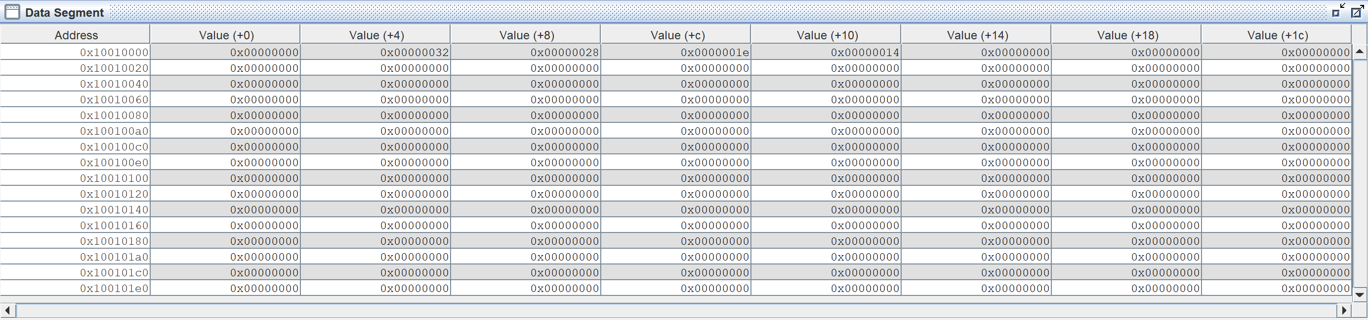Here, we are using the temporary registers in this code which is the difference from part 2-2_1.

Figure 7. Data segment for 2-2_2.asm

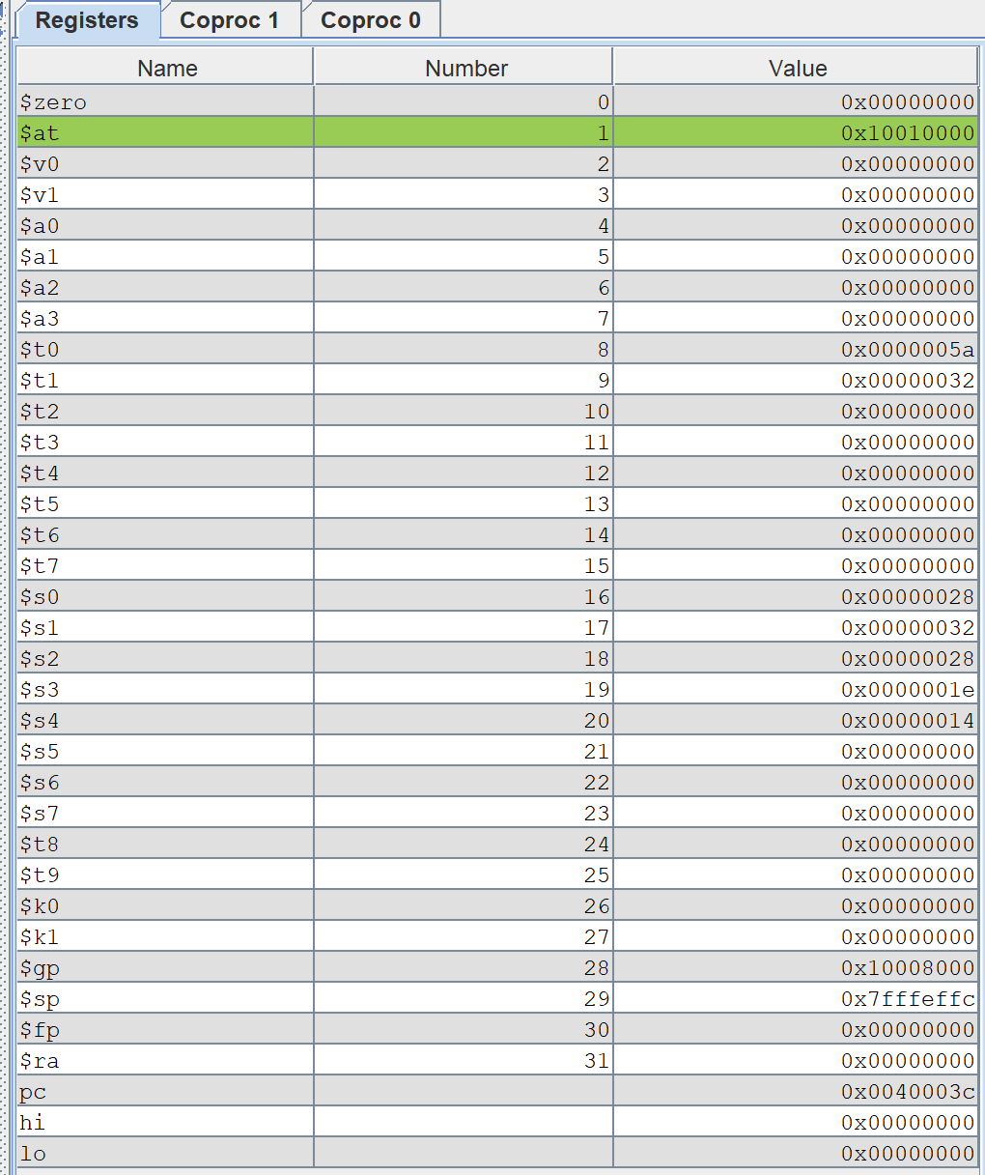

Figure 8. Registers segment for 2-2_2.asm

## 2-3_1.asm

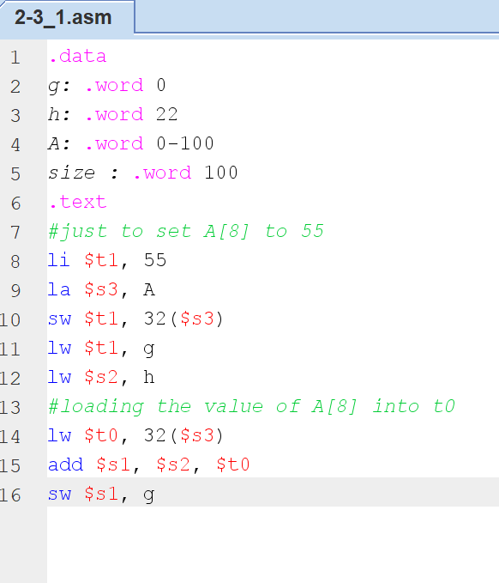

Figure 9. 2-3_1.asm code in Mars

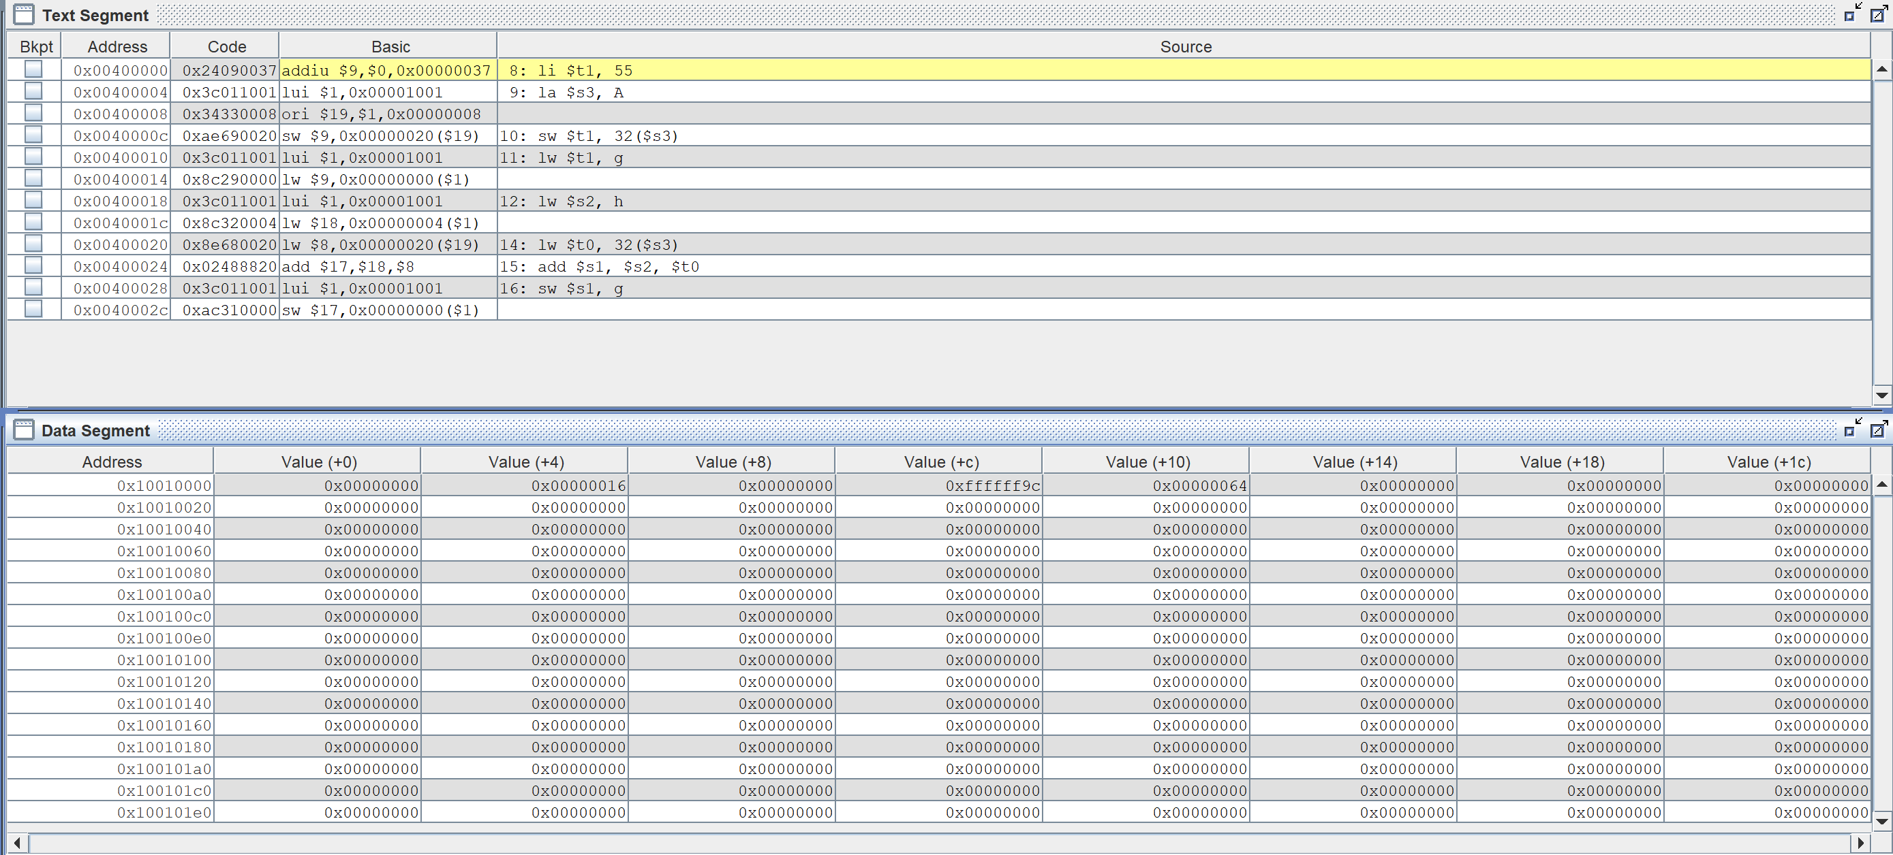We're using temporary registers and storing $s3 at a 32-bit offset. Because we are storing to A[8], and each hexadecimal value has four bytes, we must multiply 8 * 4 to get the offset value. This is not the beginning of array A.

Figure 10. Text and data segment for 2-3_1.asm co

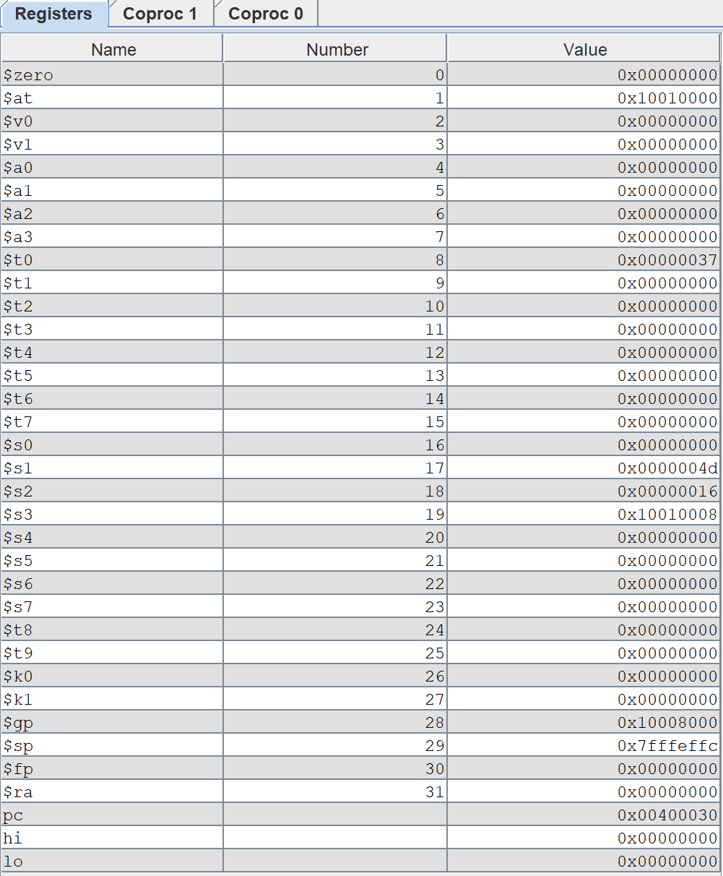

Figure 11. Registers portion for 2-3_1.asm

## 2-3_2.asm:

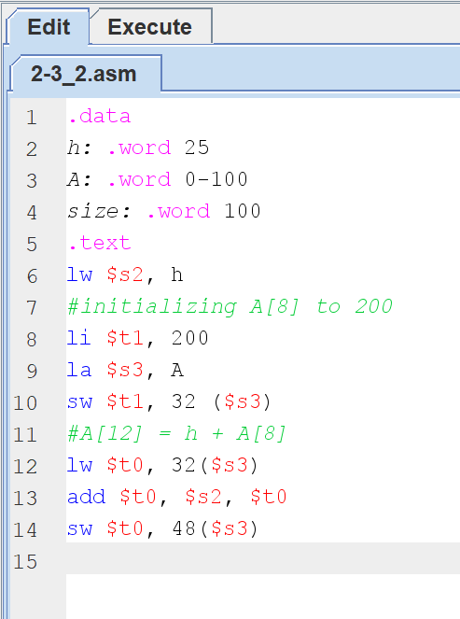

Figure 12. 2-3_2.asm code

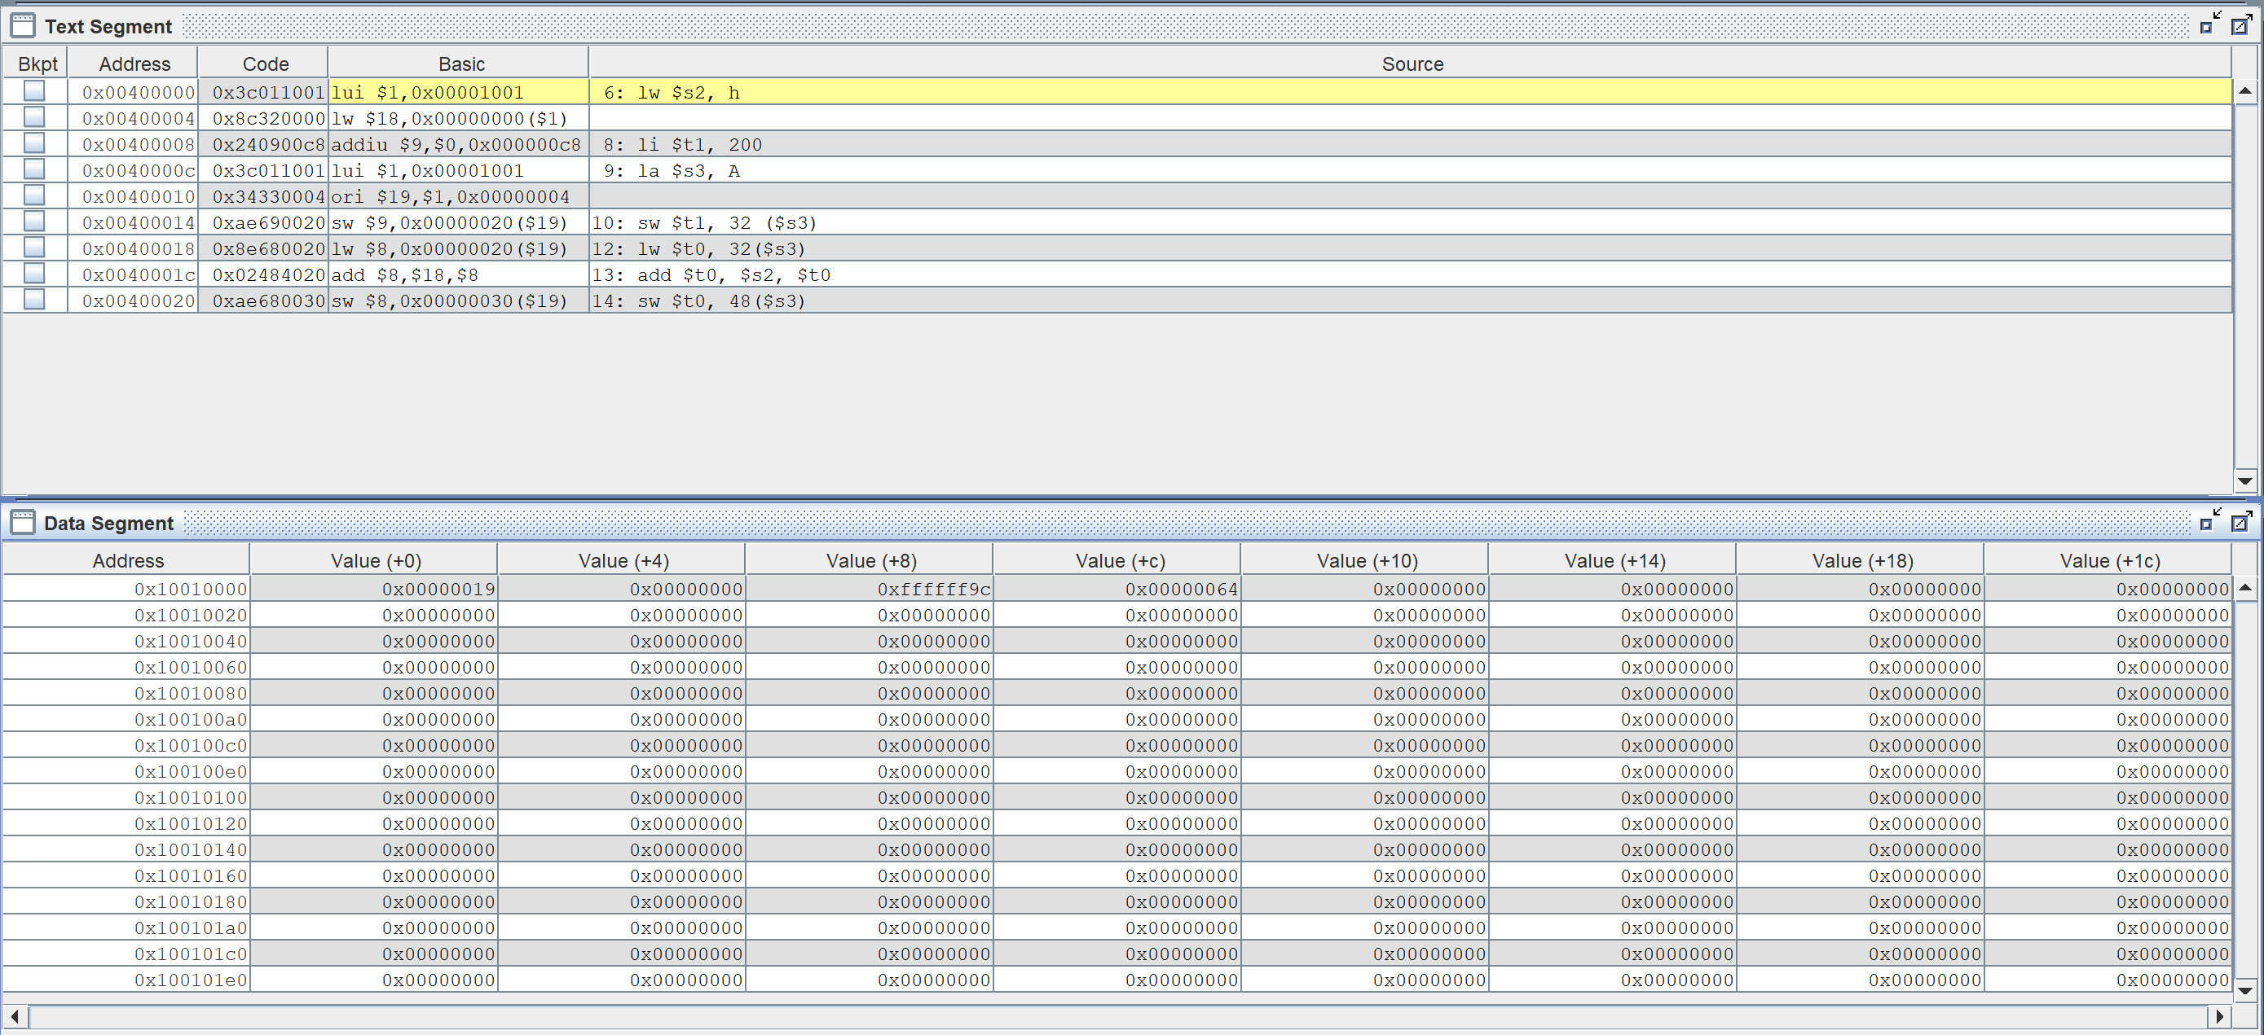

Figure 13. Text and data segment for 2-3_2.asm code

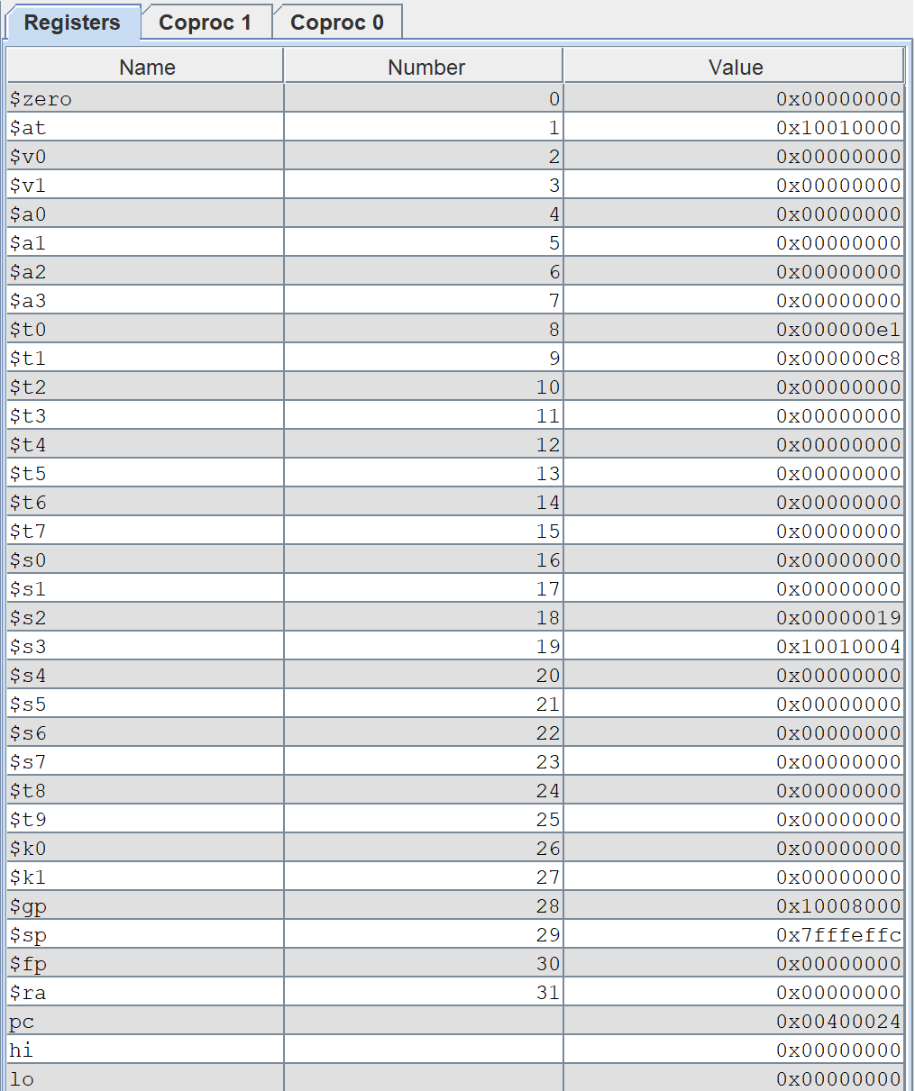

Figure 14. Registers for 2-3_2.asm code

## 2-5_2.asm:

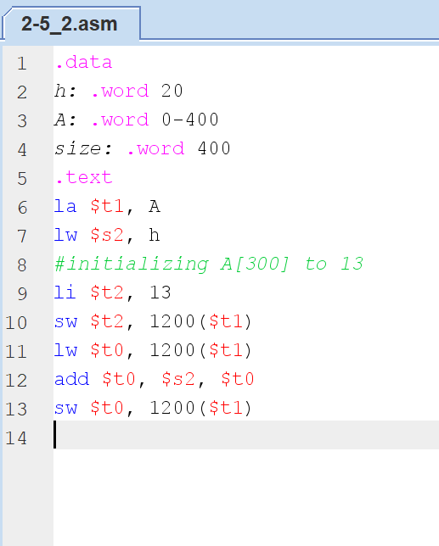

Figure 15. 2-5_2.asm code in Mars

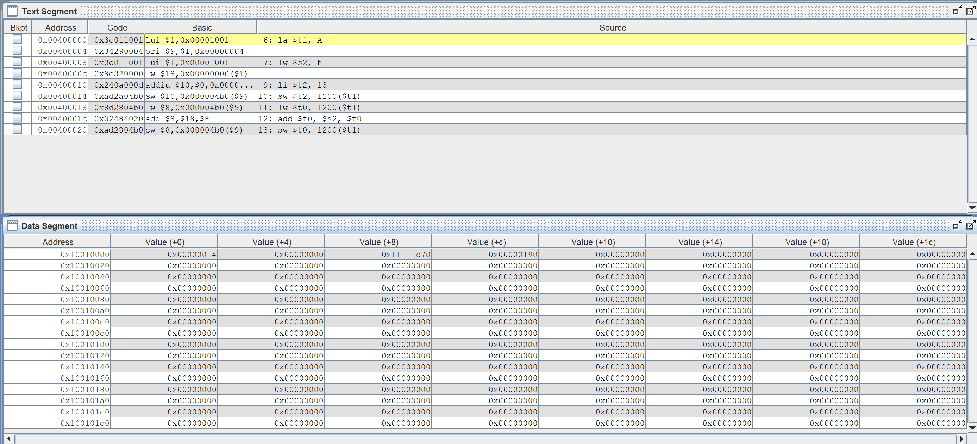

Figure 16. Text and data segment for 2-5_2.asm code

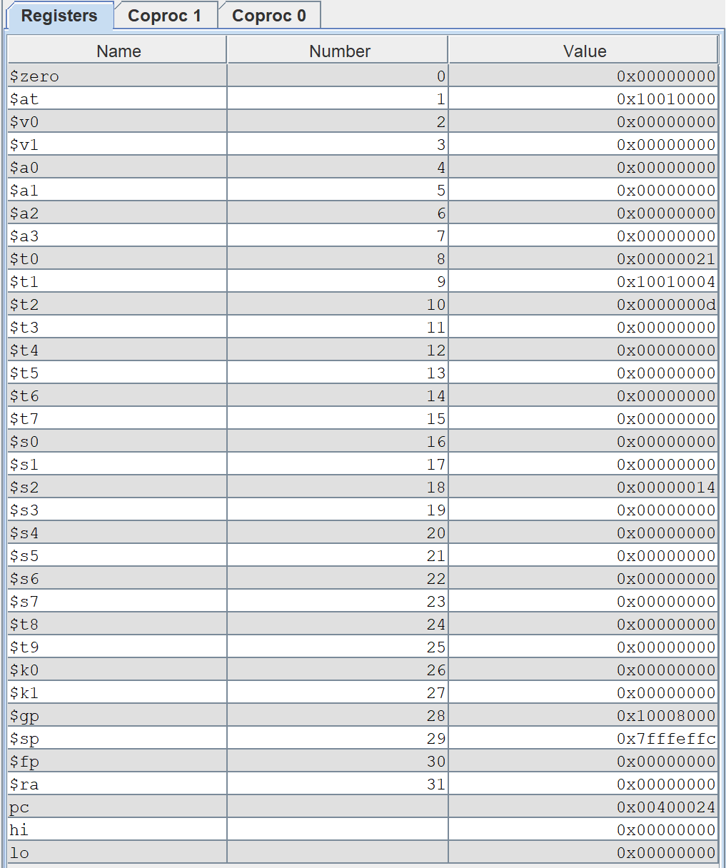

Figure 17. Registers for 2-5_2.asm

## 2-6_1.asm:

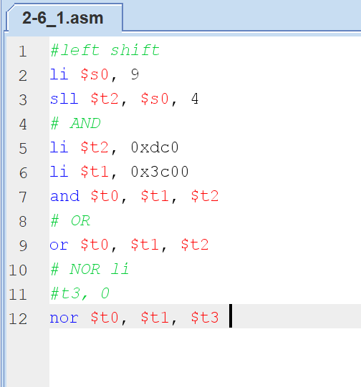

Figure 18. 2-6_1.asm code in Mars

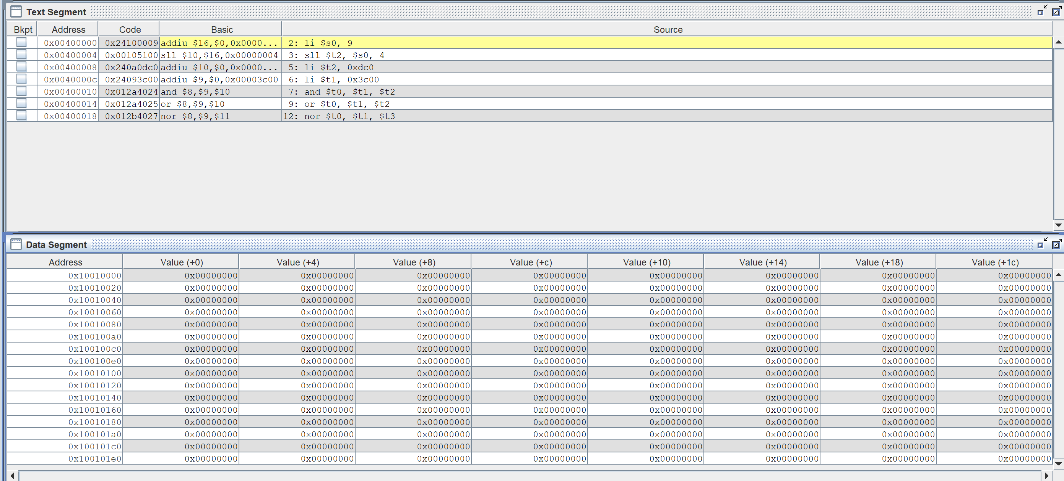

Figure 19. Text and Data segment for 2-6_1.asm code

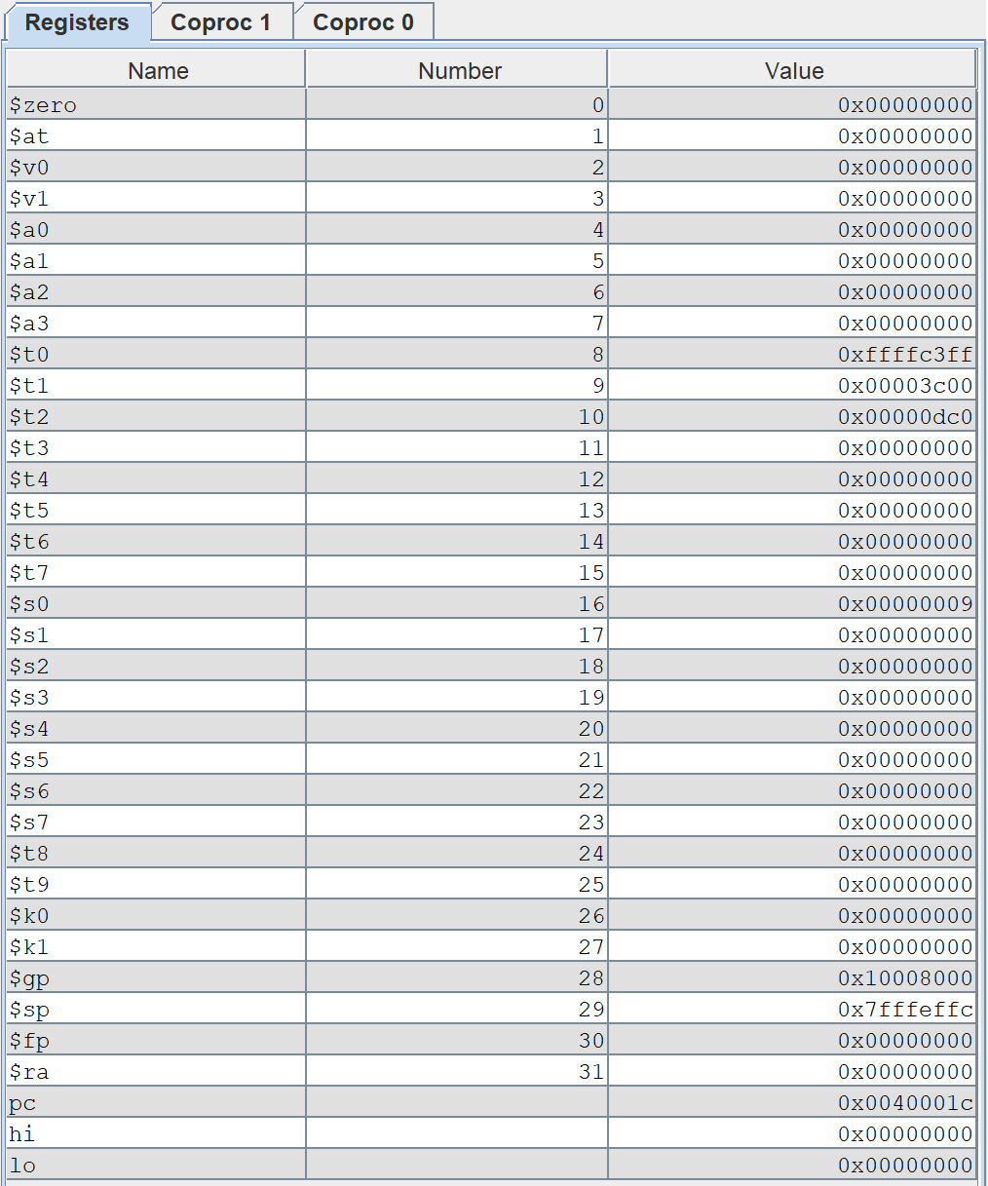

Figure 20. Register for 2-6_1.asm code

## While-Loop:

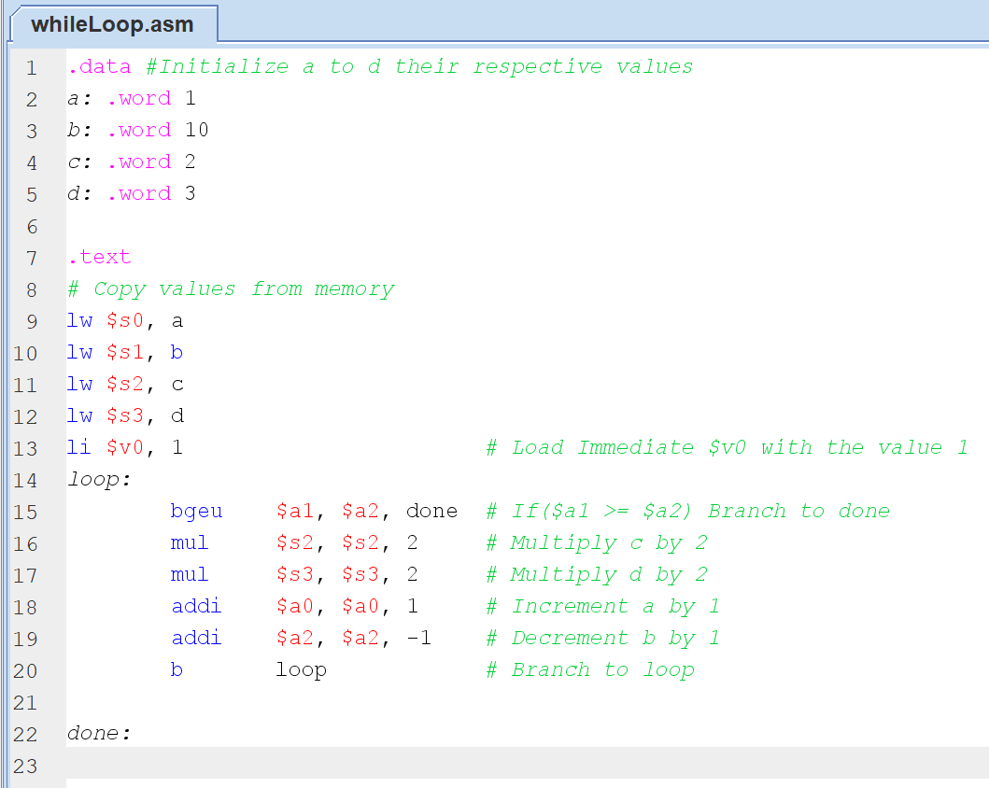

Figure 21. whileLoop.asm code in Mars

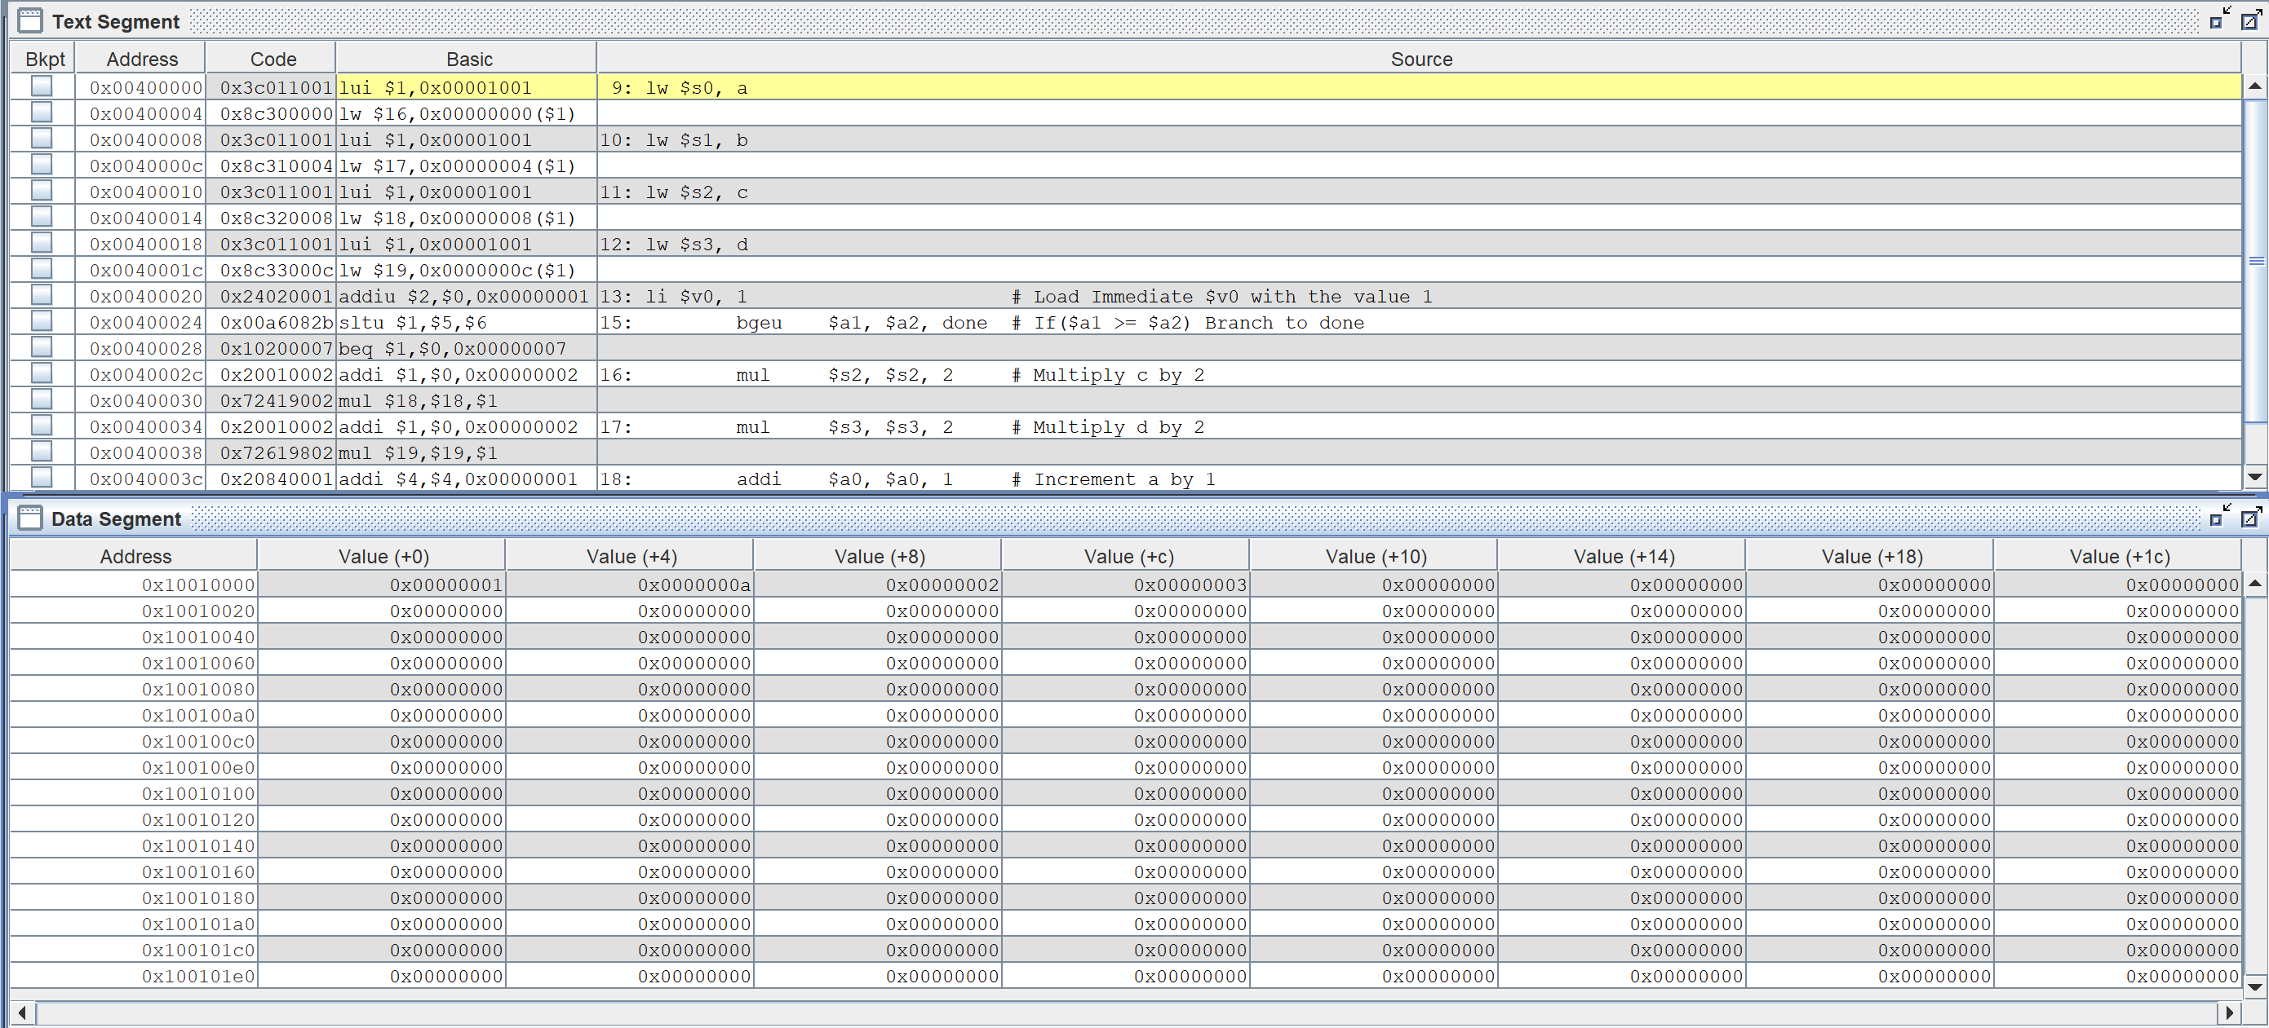

Figure 22. Text and Data segment for whileLoop.asm

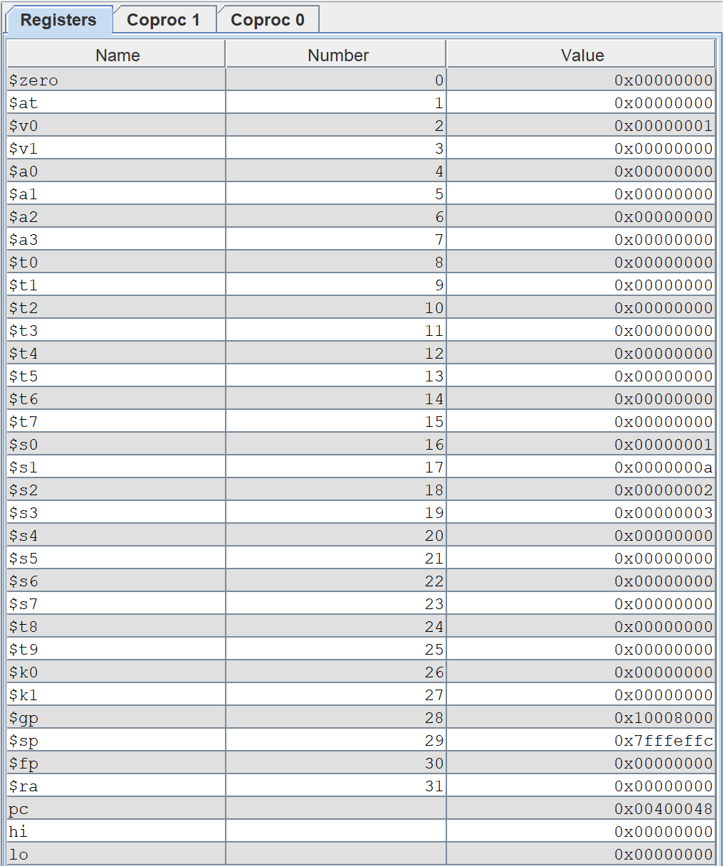

Figure 23. Registers for whileLoop.asm

The following is an example of MIPS using while statement. This MIPS code is equivalent to the C code shown below:

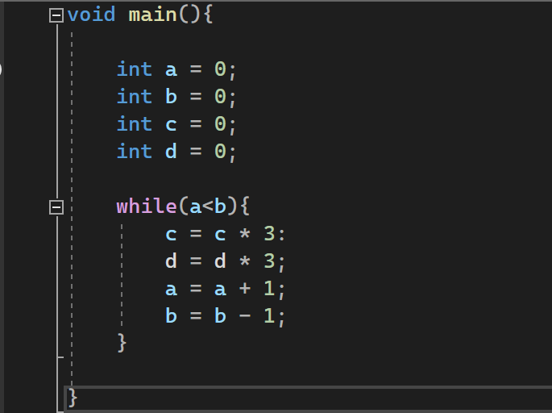

Figure 24. while loop .c file equivalent to mips

## For Loop:

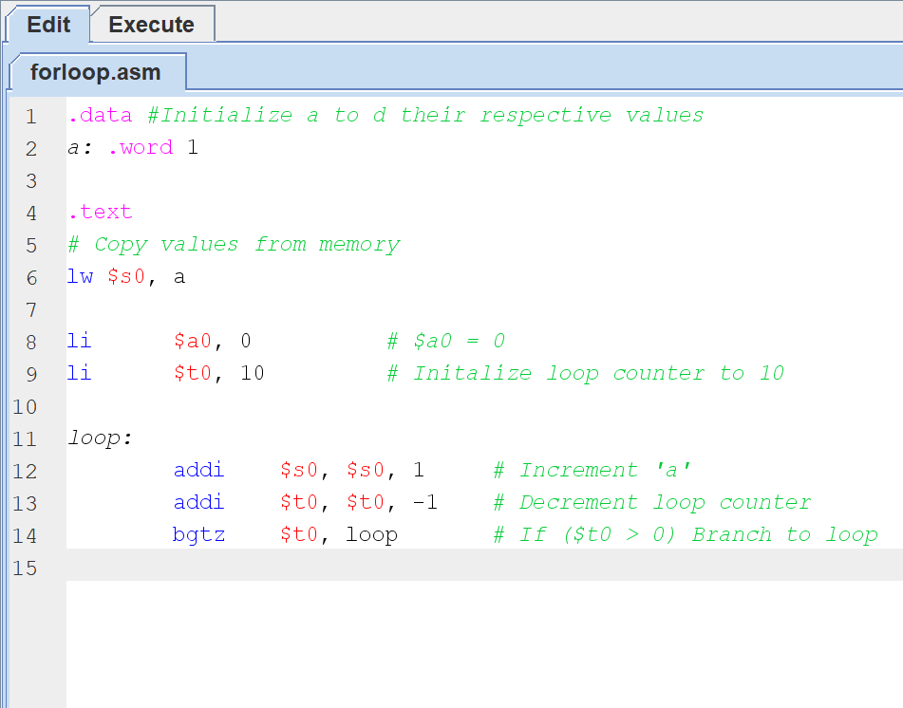

Figure 25. For loop code in Mars

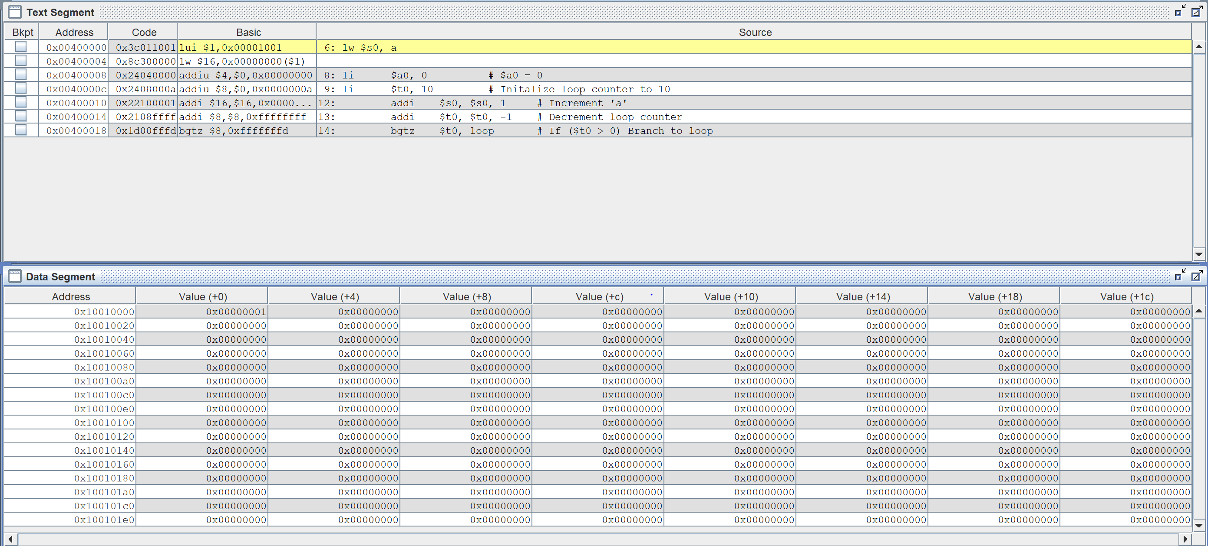

Figure 26. Text and Data segment for forloop code

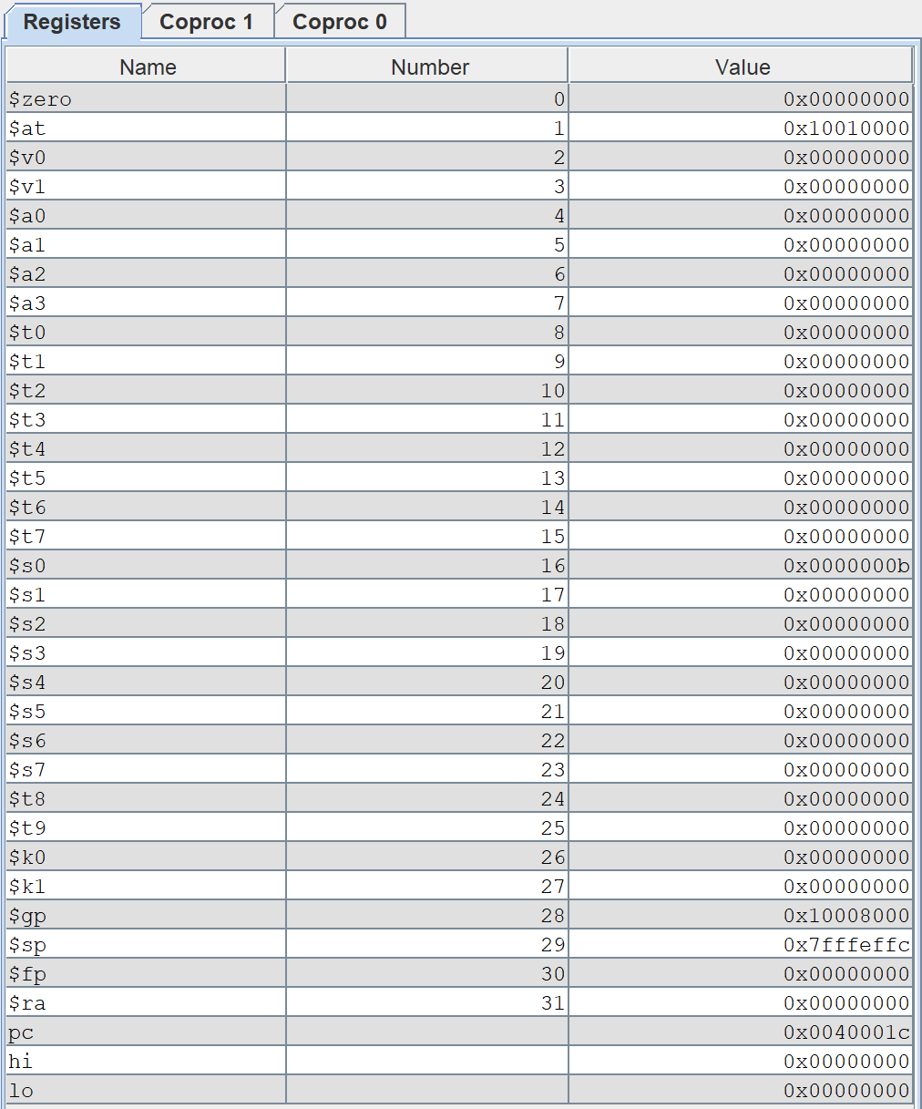

Figure 27. Registers for forloop code

The following is an example of MIPS using a for-loop statement. This MIPS code is equivalent to the C code shown below:

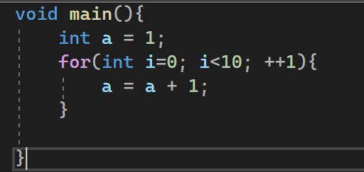

Figure 28. forloop.c equivalent of mips file

## If-Then-Else:

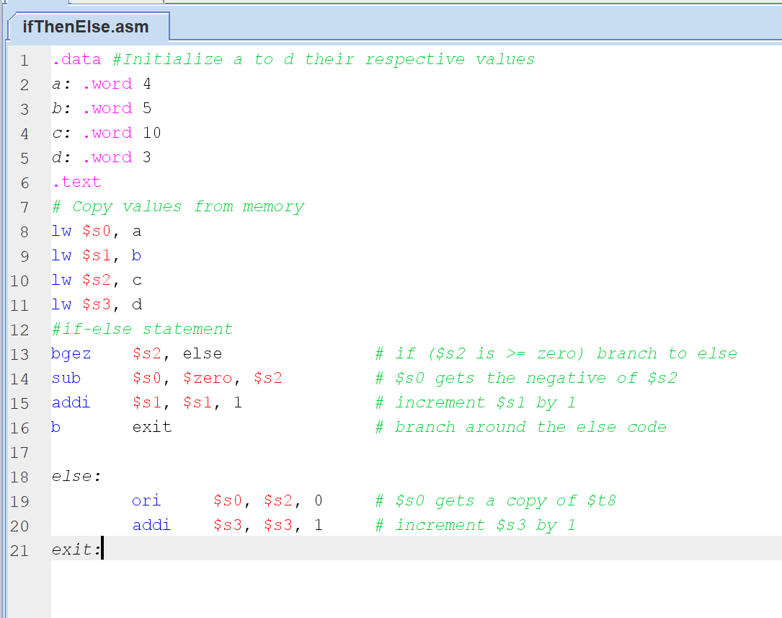

Figure 29. If-then-else.asm code in Mars

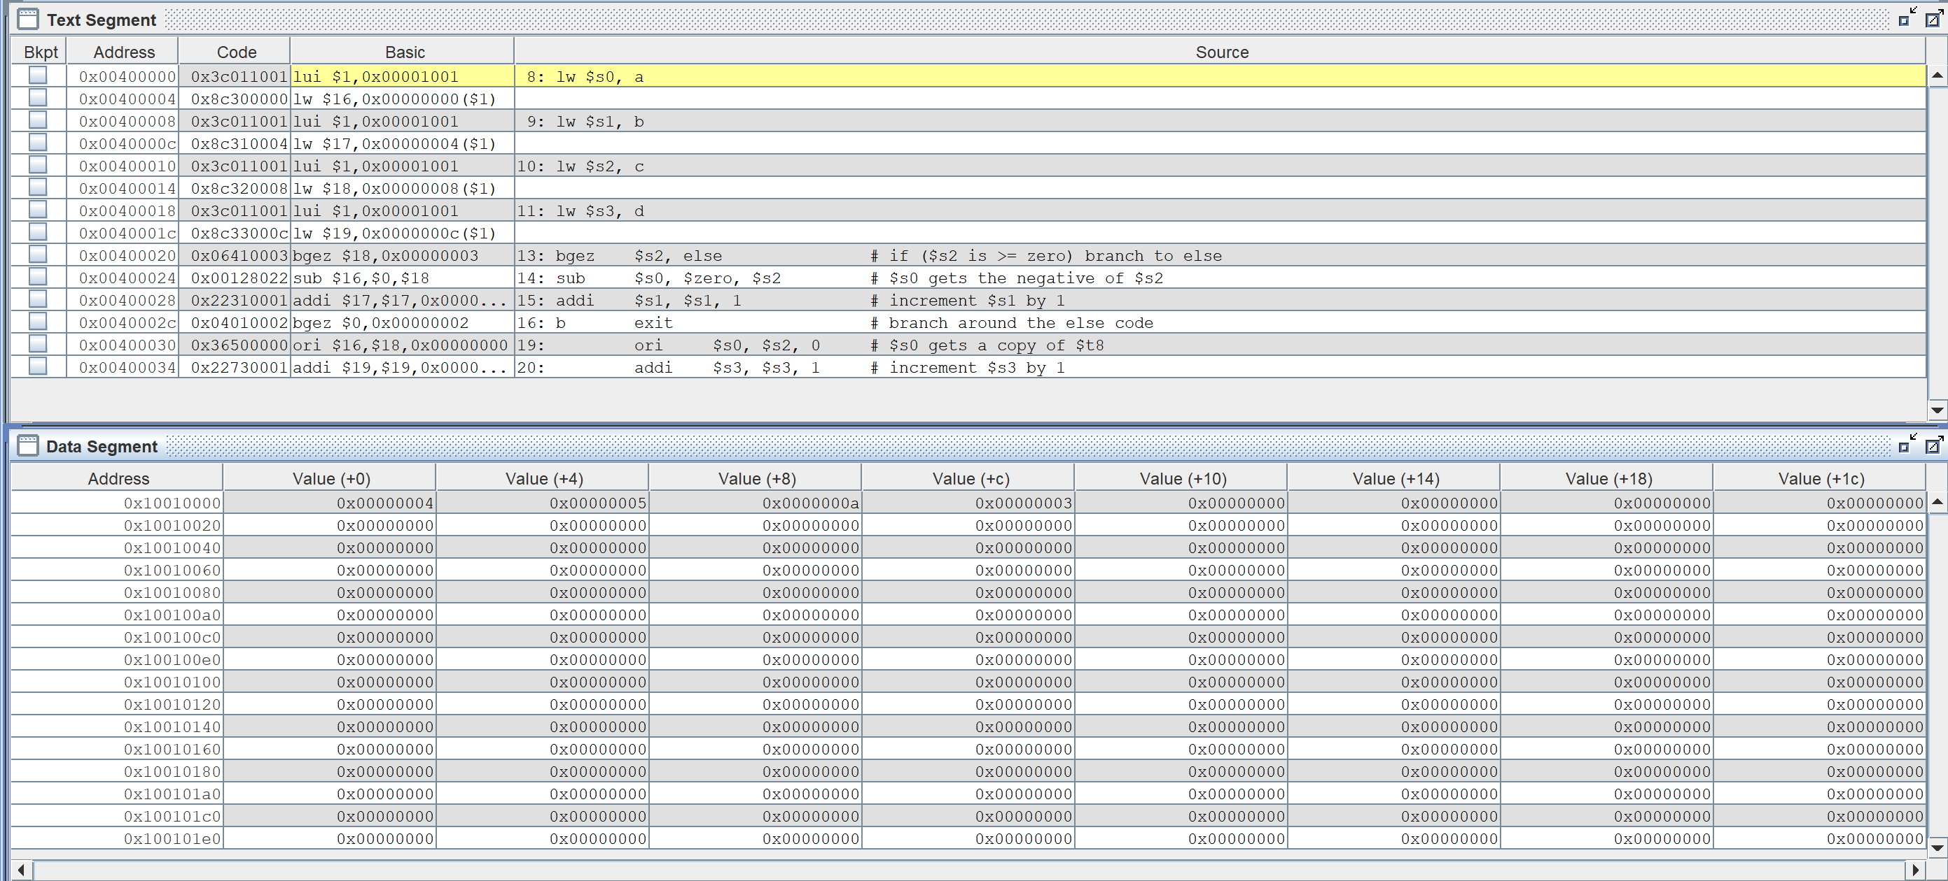

Figure 30. Text and Data segment for if-then-else.asm code

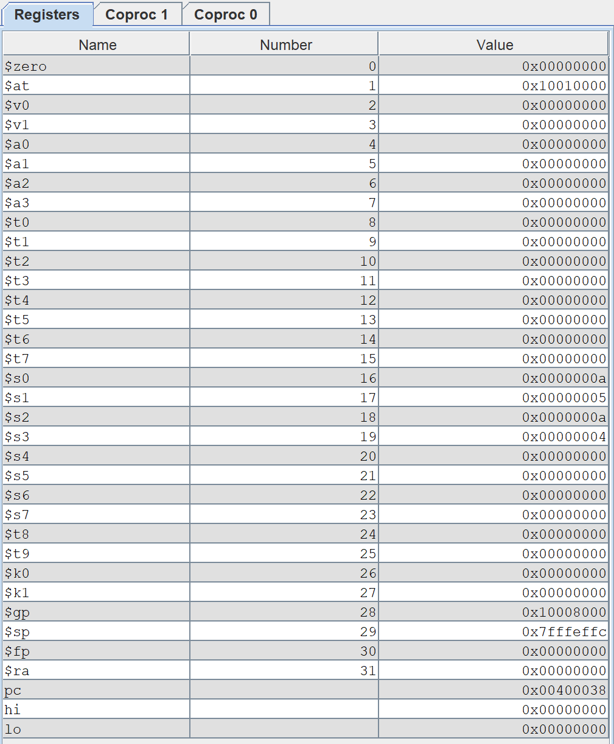

Figure 31. Registers for if-then-else code

The following is an example of MIPS using an if-else statement. This MIPS code is equivalent to the C code shown below:

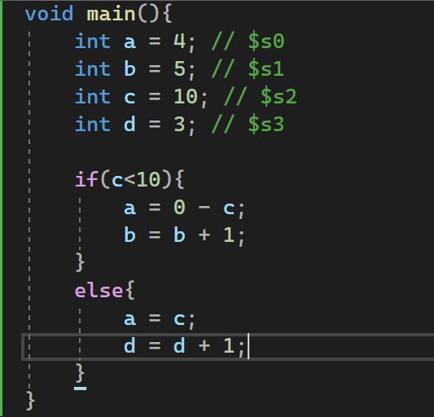

Figure 32. ifThenElse.c equivalent to mips

## Section 2.8: Write a simple “MAIN” in MIPS assembly that calls “myadd” function and analyze

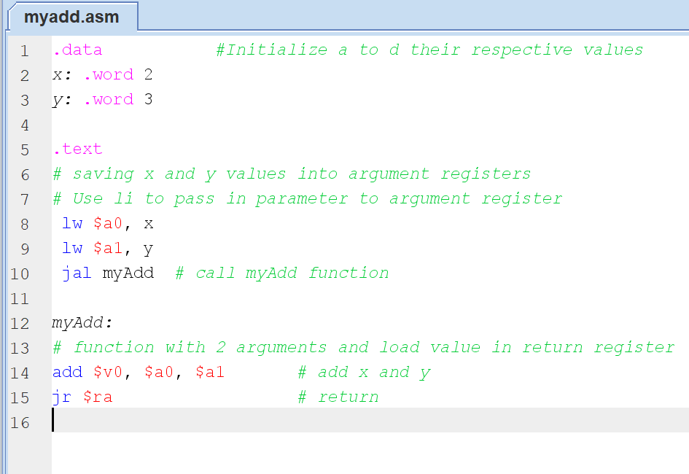

Figure 33. myadd.asm in MARS

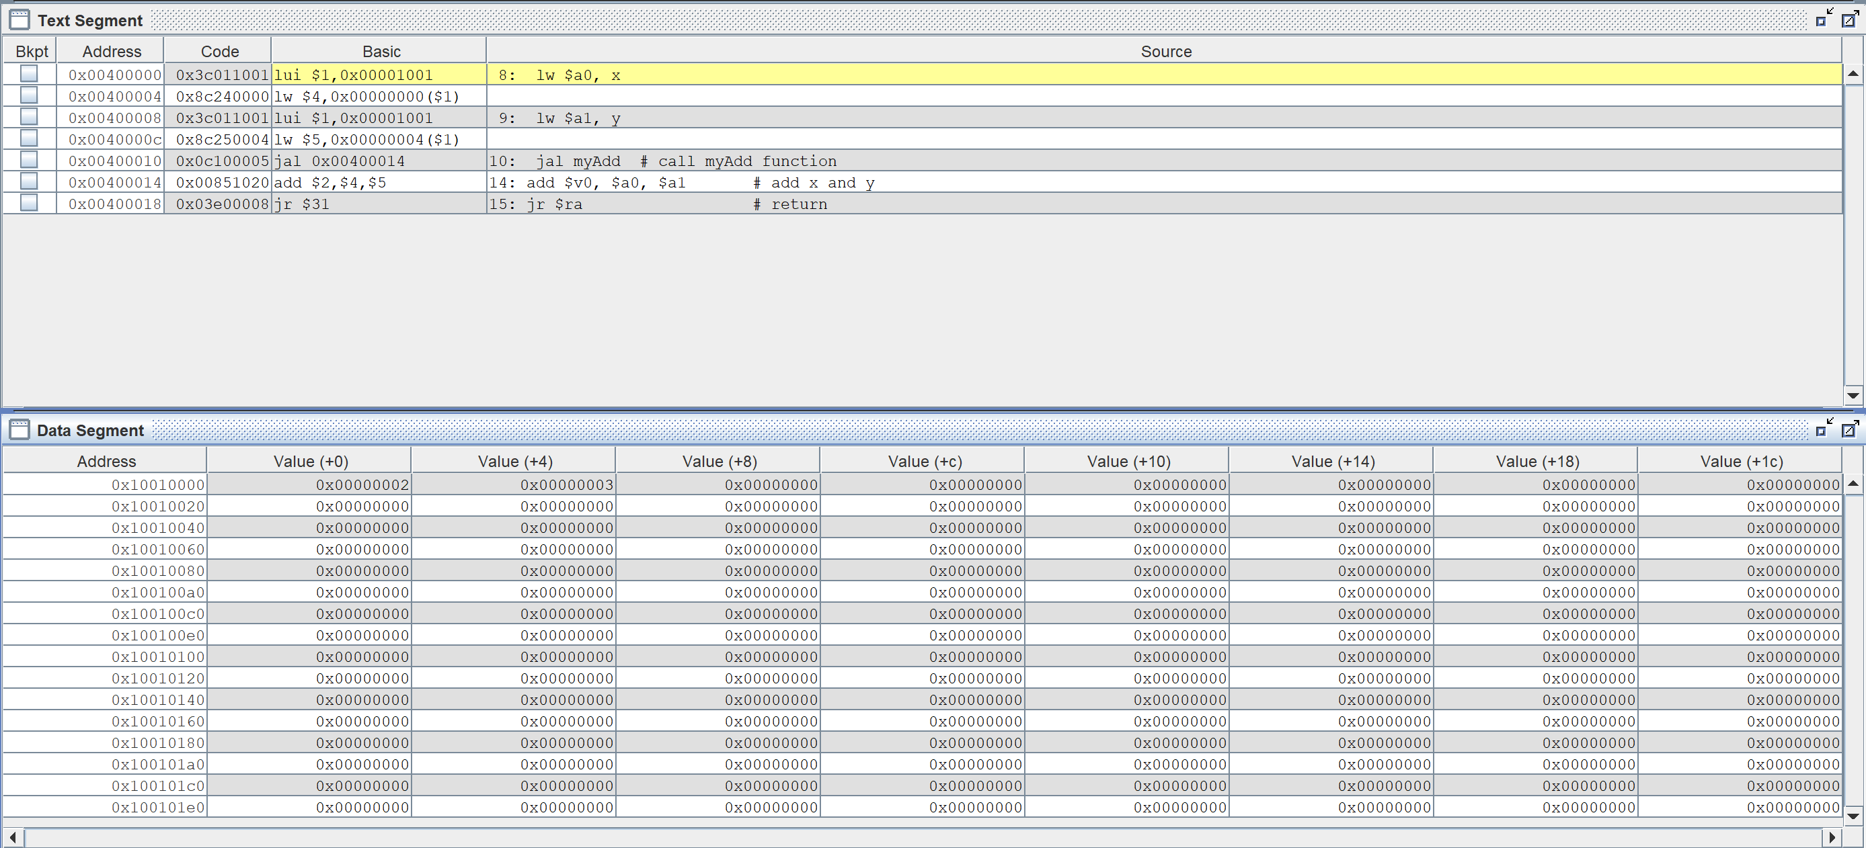

Figure 34. Text and Data segment for myadd code

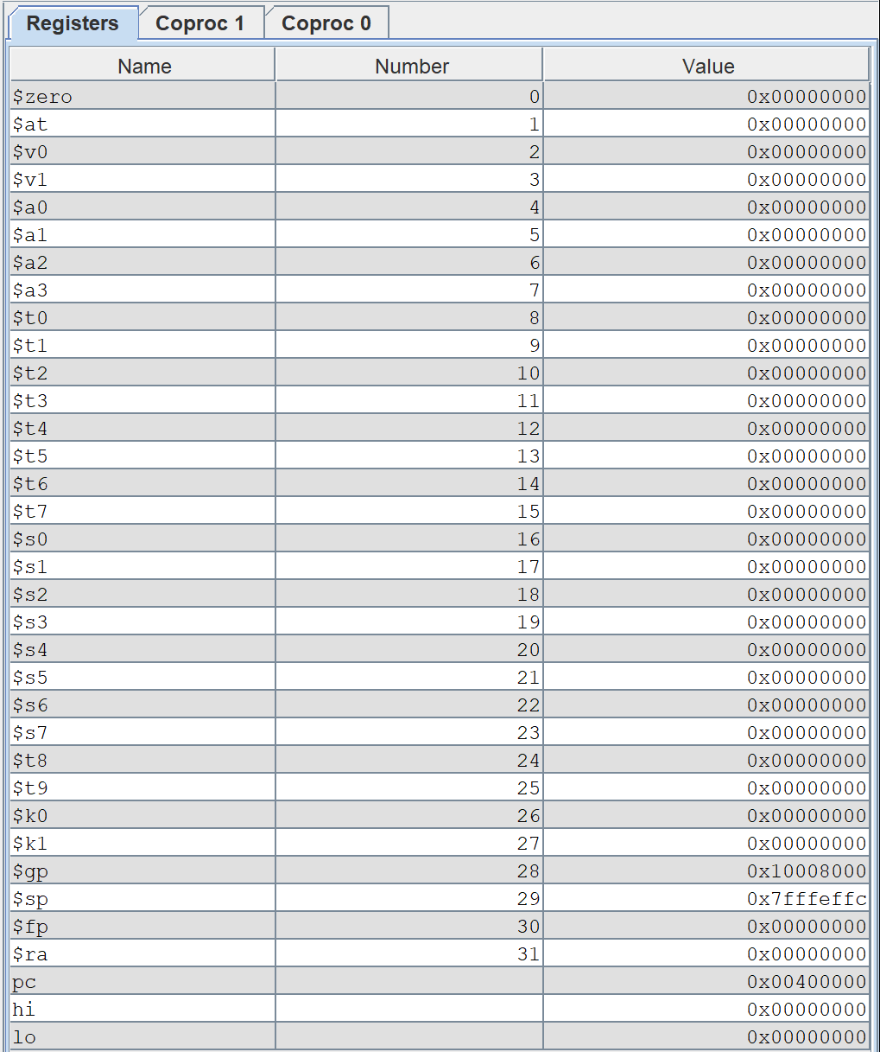

Figure 35. Registers for myadd.asm

# Part 2: Intel x32 ISA in Microsoft Visual Studio

The actual C code, as well as its disassembly, memory, and registers, will be shown in the accompanying images for Part 2. I'll go over the parts of a disassembly, memory, and registers windows utilizing 2- 2_1, but I'll go over the parts of a disassembly, memory, and registers windows separately. Consider the following example.

## 2-2_1.c

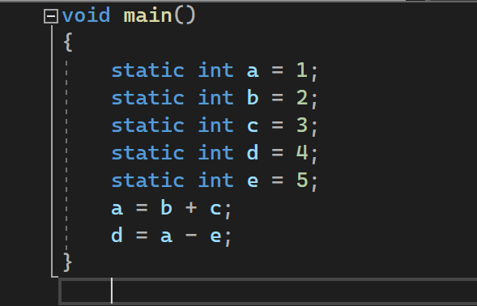

Figure 36. 2-2_1.c

It's pretty easy to tell what's local, static, and local static variables in Intel X32. If a variable has the static keyword before the int, it is considered static. A local variable is defined within a function, including the main function, and does not have the term static.

A static local variable, on the other hand, would have the keyword static, but it would be defined in a user-defined function rather than the main function. Because it is defined in the main function, the image above illustrates a simple static variable.

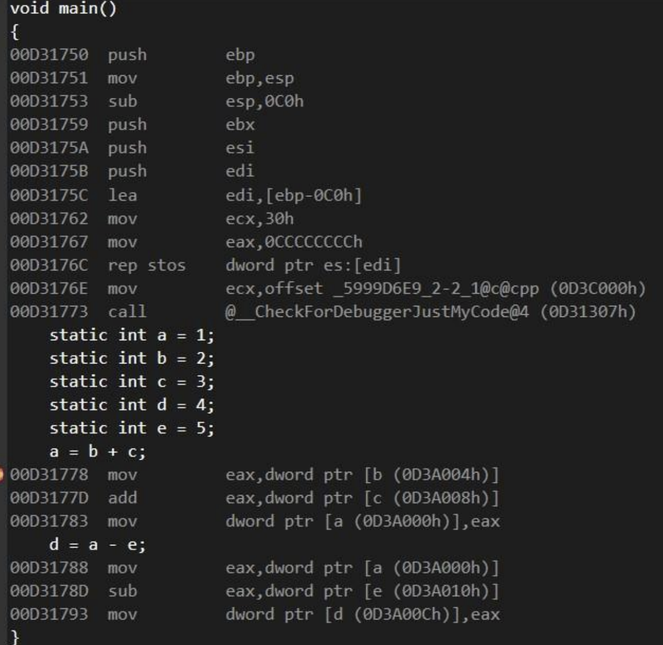

Figure 37. 2-2_1.c disassembly

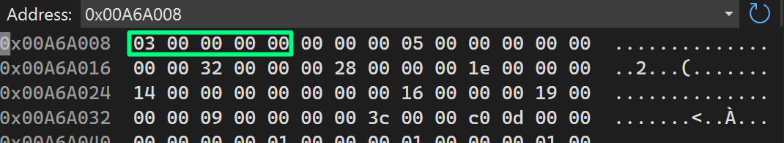

Figure 38. 2-2_1.c memory window VS

The above picture is the memory window.

Endian is the method of storing multiple-byte data in computers, such as short, int, long, float, and double. Data in Intel X32 is stored in a format known as "Little Endian." This signifies that the data's initial byte is saved last. Consider the address 0x00A6A008, which is presented in the first row of the memory pane. "03 00 00 00" is the value assigned to that address. The most significant bits are kept last since it is stored in little endian. As a result, the address's true value is "00 00 00 03." In general, Little Endian is preferable to Big Endian. The main advantage of Little Endian is that the value in a range of types is easy to read.



Figure 39. register window

There are 10 registers in Intel X32 as shown in the register window. I will go over all these registers.

EAX : Accumulator register which is used for I/O port access, arithmetic, interrupt calls, etc.

ECX : Counter register which is used as a loop counter and for shifts.

ESI / EDI : General purpose registers that can only add register values

EIP : Instruction pointer that points to the first byte of the next instruction to be executed.

EBP : Frame pointer that contains the base address of the functions’ frame

EBX : Base register, which is used for memory access

EDX : Data register, which is used for I/O port access, arithmetic, some interrupt calls

ESP : Stack pointer which means it holds the top of the stack.

EFL : Short for EFLAGS, contains a set of flags that control the operation of the CPU

## 2-2_2.c

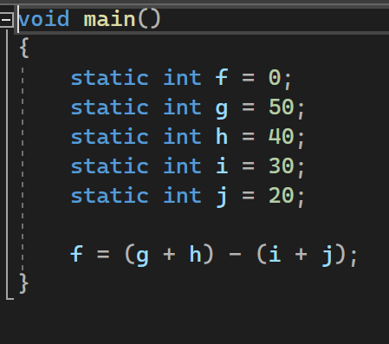

Figure 40. 2-2_2.c in VS

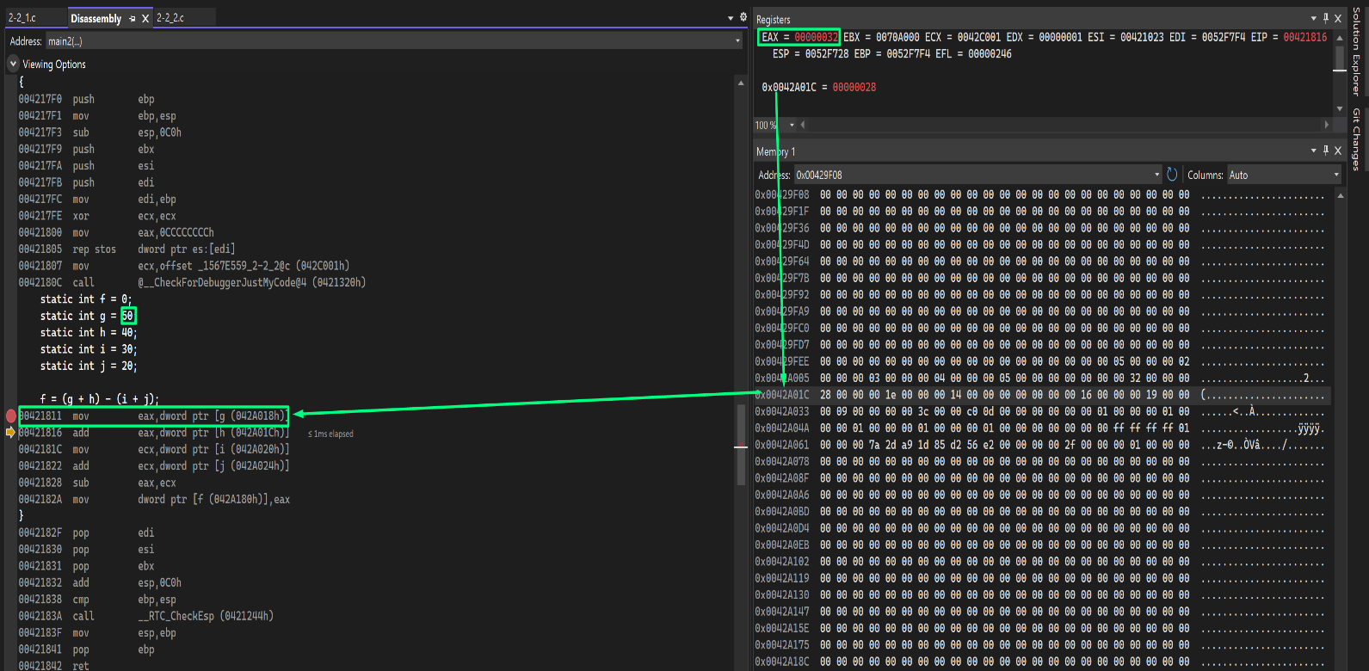

Figure 41. variable g being stored.

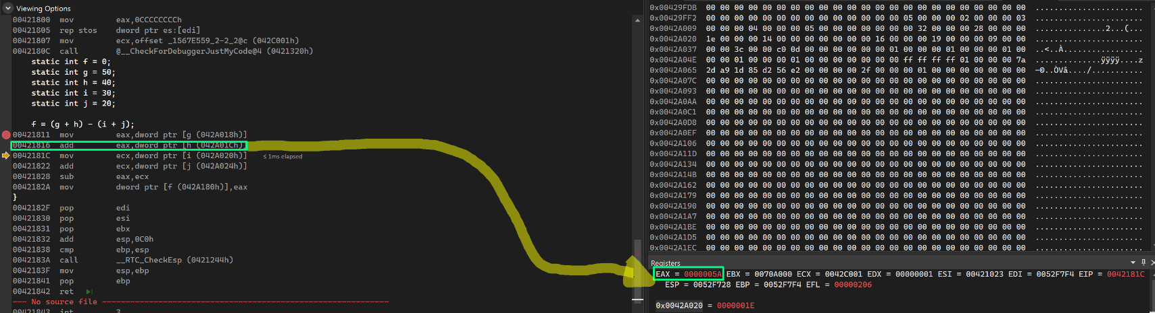In figure 41, we see that g is stored in EAX register then into memory.

Figure 42. adding g+h.

In this figure we see that g and h are being added and then the result is stored in EAX and in the memory.

## 2-3_1.c

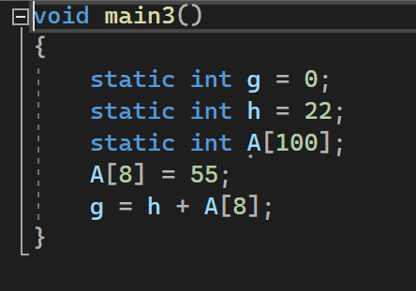

Figure 43. 2-3_1.c code

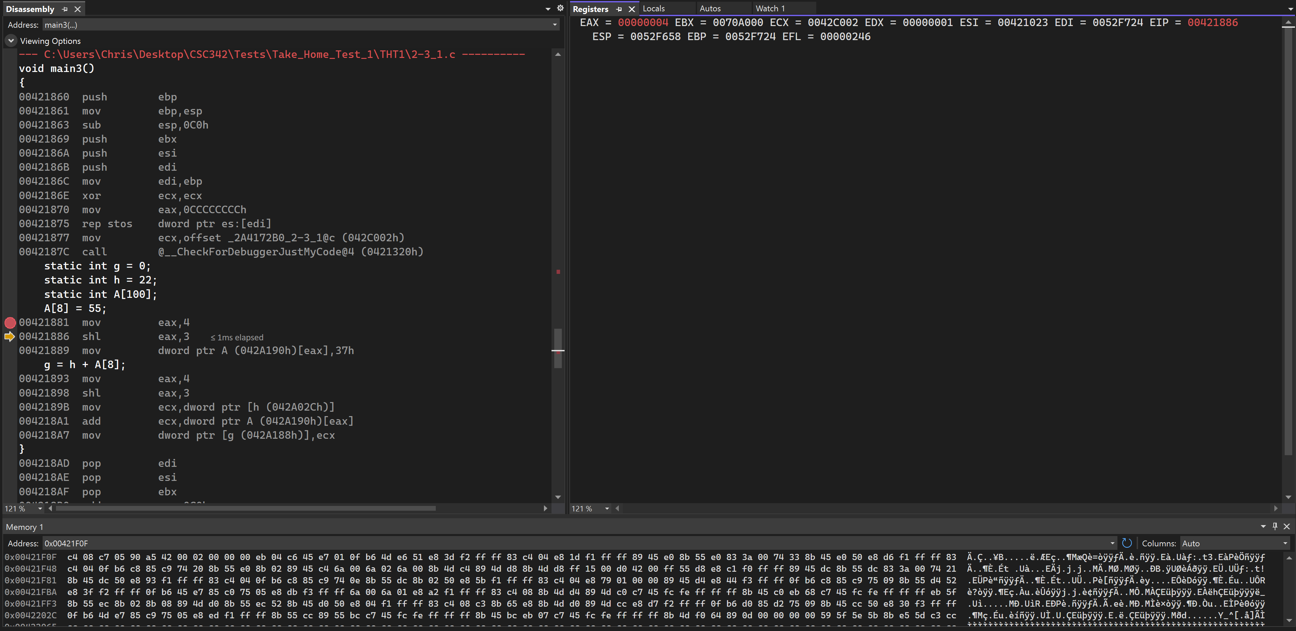

Figure 44. EAX with 4 moved into it

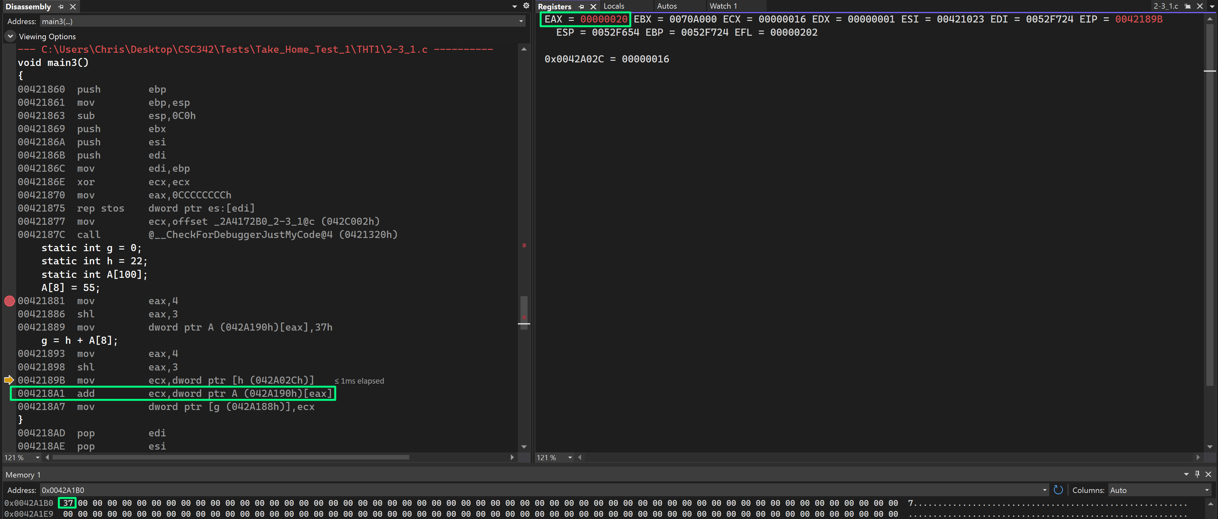

Figure 45. Shift to left,store 55 in 8th index

In the figure above, we can see that shifting the bits in the register to the left does the same task and multiplying 2 to 3rd index which is also 8. It causes the register EAX to have 32 which is equivalent to 20 in hex. We then store this 37H which is 55, into memory for the array. However, we store it in the array with offset of 32 from base address of A.

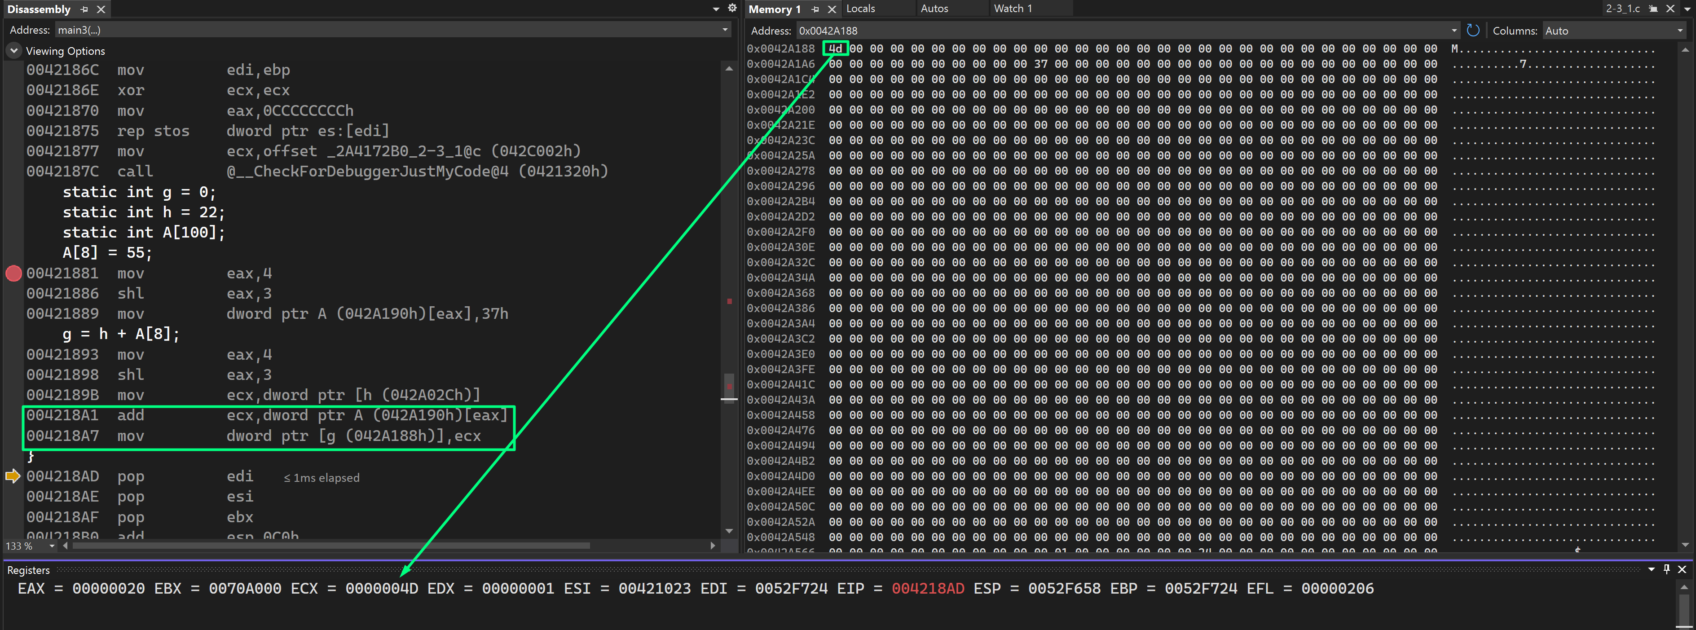

Figure 46. move + add op on arrary and h

The value of the 8th array element, 55, is added to h, which is saved in register ECX, and then relocated to the variable g, which is memory address 0x05A140h.

## 2-3_2.c

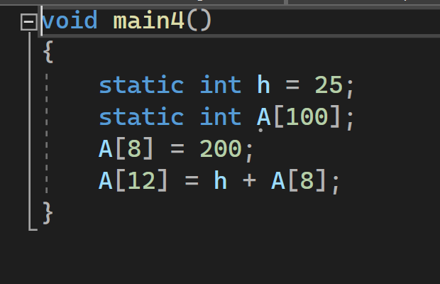

Figure 47. 2-3_2.c code

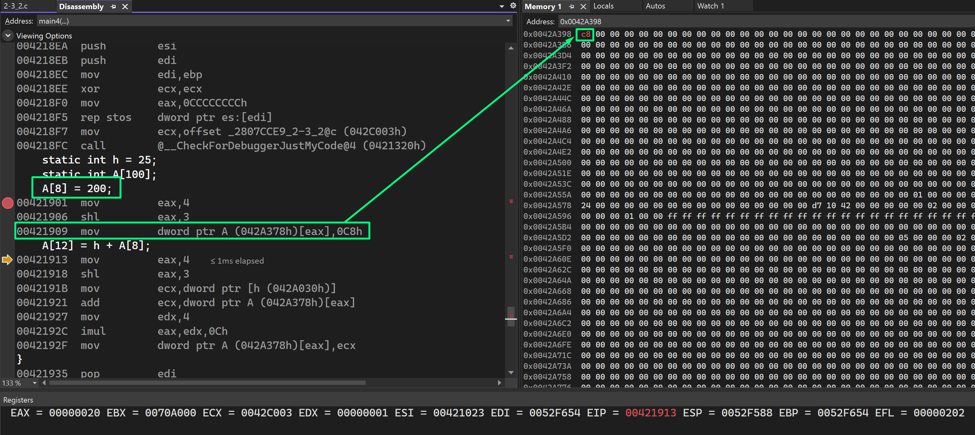

Figure 48. 200 stored in array which is in memory.

In this figure, 200 is set into memory address.

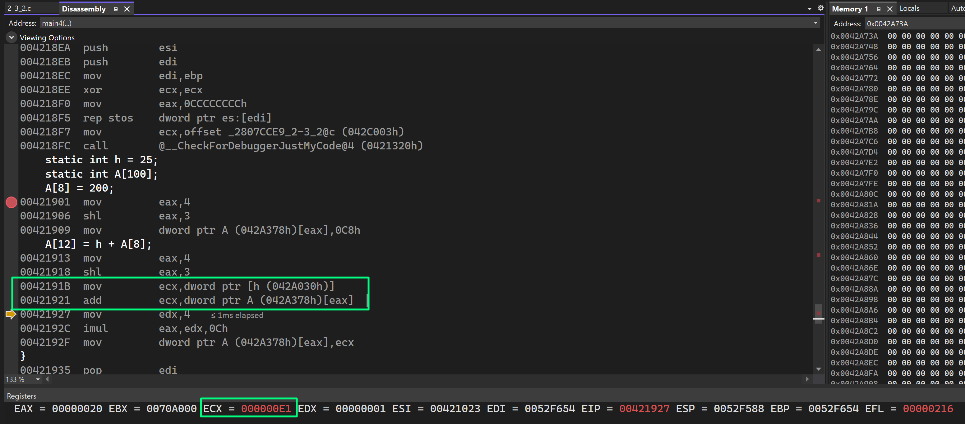

Figure 49. h + A[8] element stored into ECX

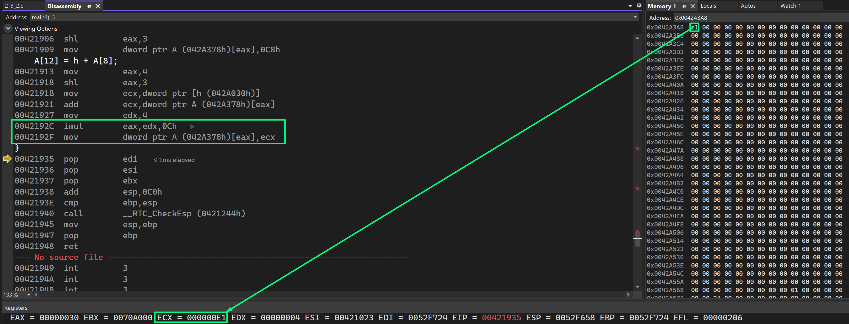

Figure 50. stored in array in 12th index

Here, the value was stored as seen in memory window.

## 2-5_1.c

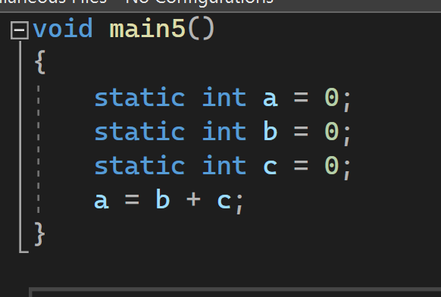

Figure 51. 2-5_1.c code

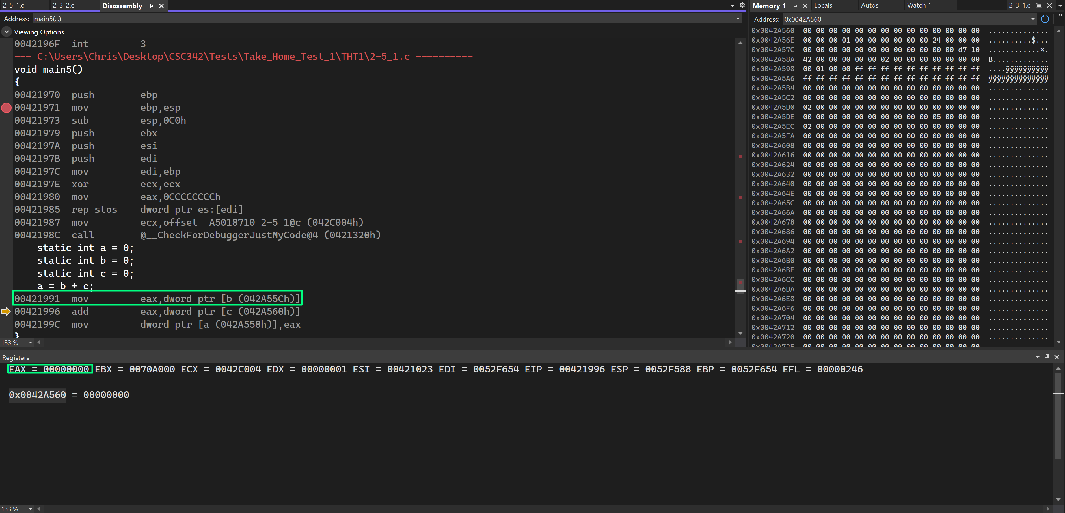

Figure 52. value of EAX is 0.

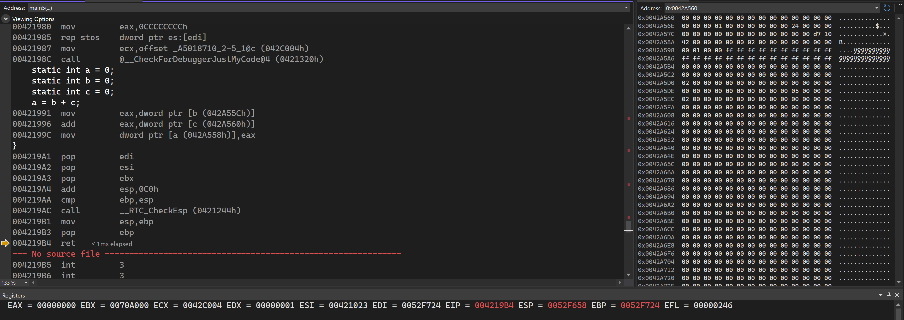

Figure 53. add + mov instruction on a.

We see that variable c is added into the contents of register EAX and then the result is then moved into a from EAX in memory.

## 2-6_1.c

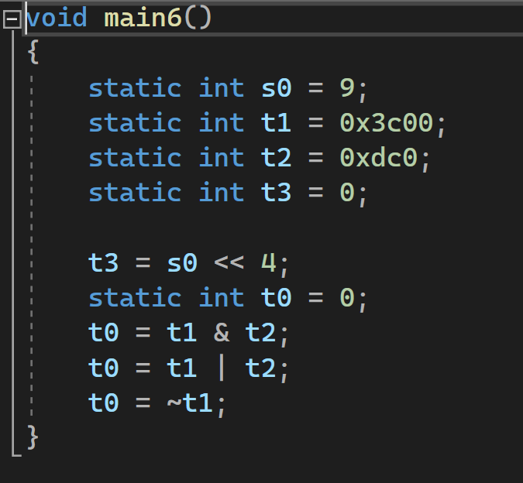

Figure 54. 2-6_1.c code

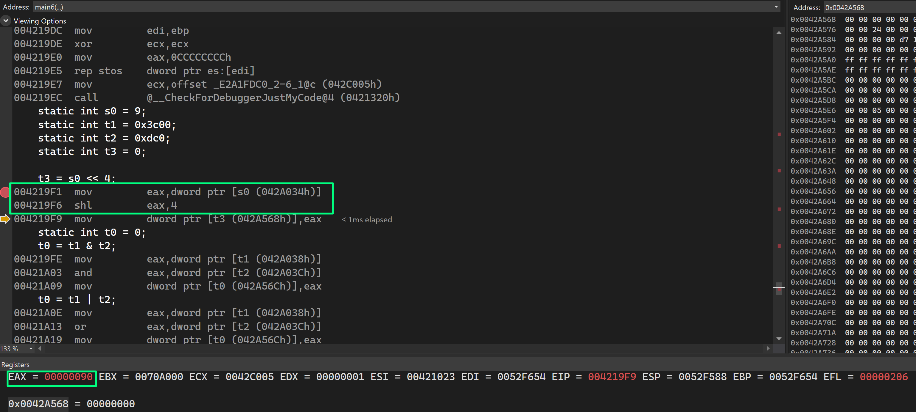

Figure 55. 9 stored in EAX, shifted left 4 bits.

Here, instructions allow the program to move 9 into EAX. From there eax, 4 tells us that it is shifted 4 bits to the left resulting in 0x90.

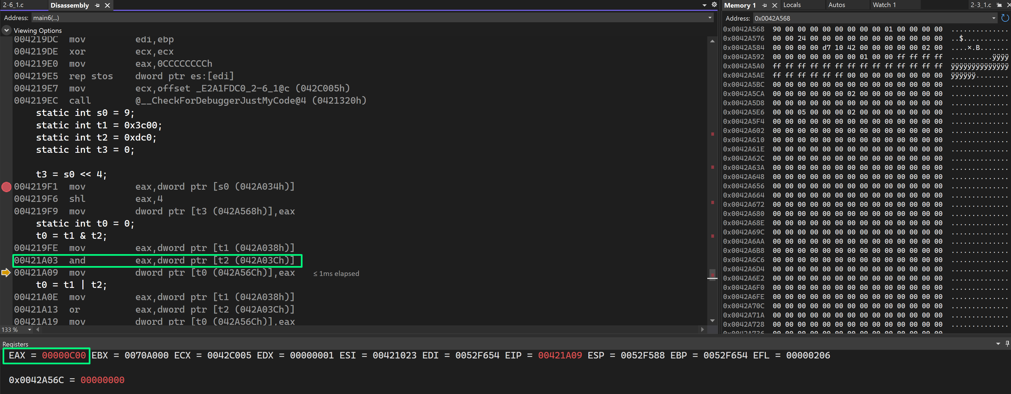

Figure 56. eax with and performed on it.

Variables t1 and t2 has had logical and operand performed on the EAX register in the figure above. See screenshot.

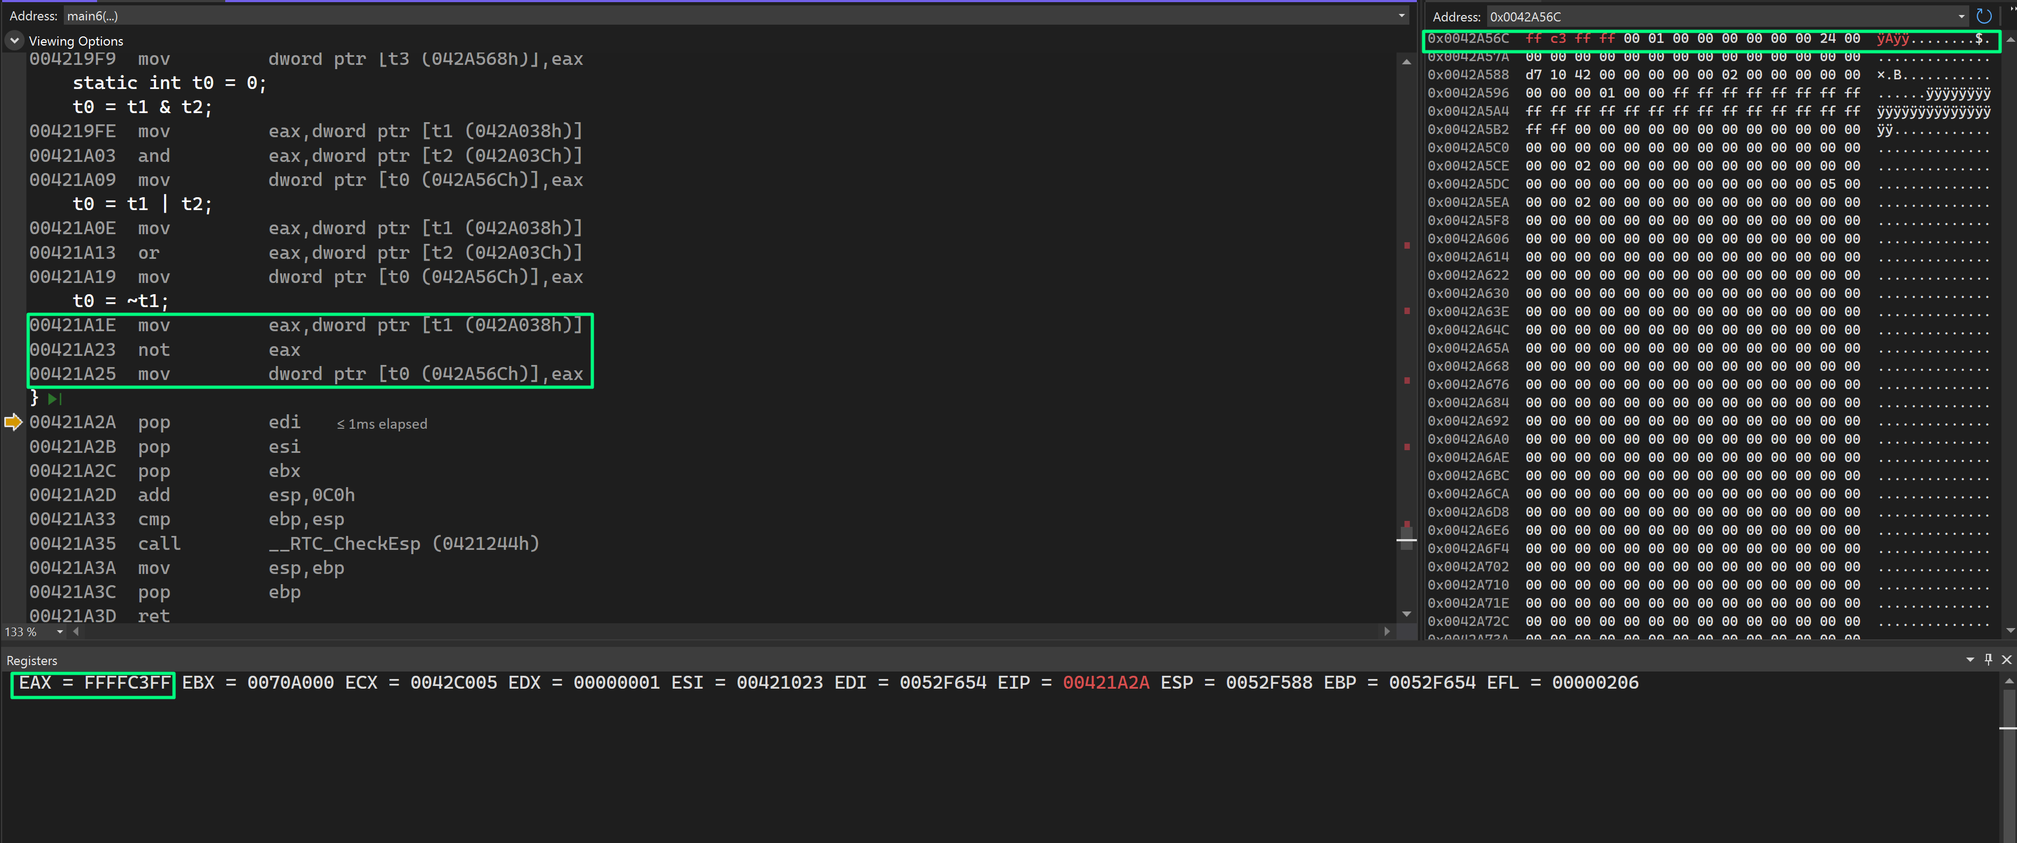

Figure 57. not operand on EAX reg.

As shown in the diagram above, variable t1 is transferred into register EAX, followed by a not operation on register EAX, and the contents of the EAX register are then put into variable t0 and stored in memory.

## Natural_generator.c

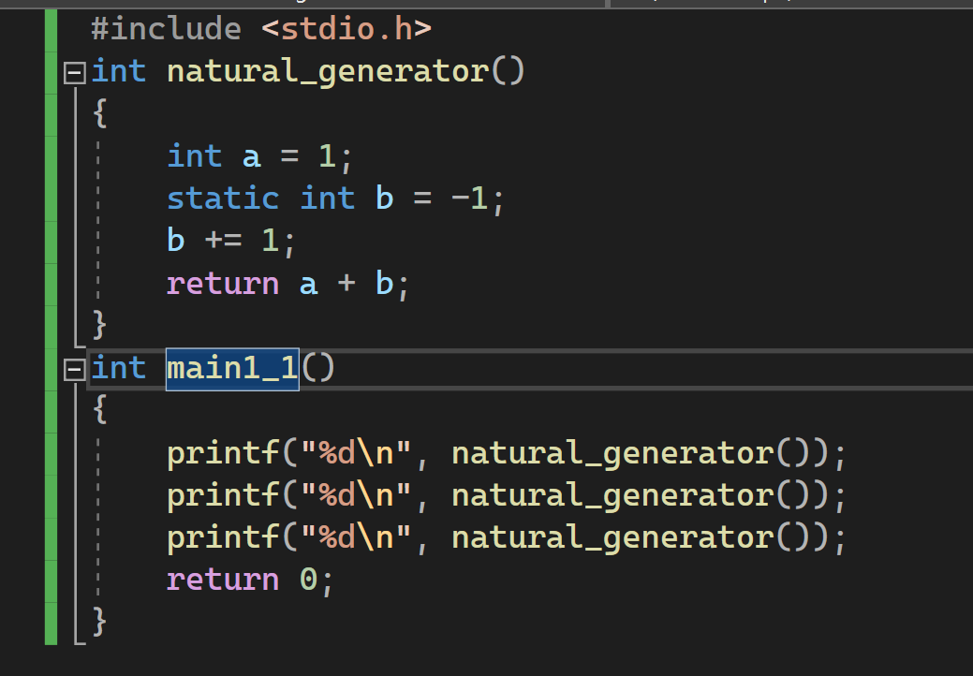

Figure 58. natural_generator.c code

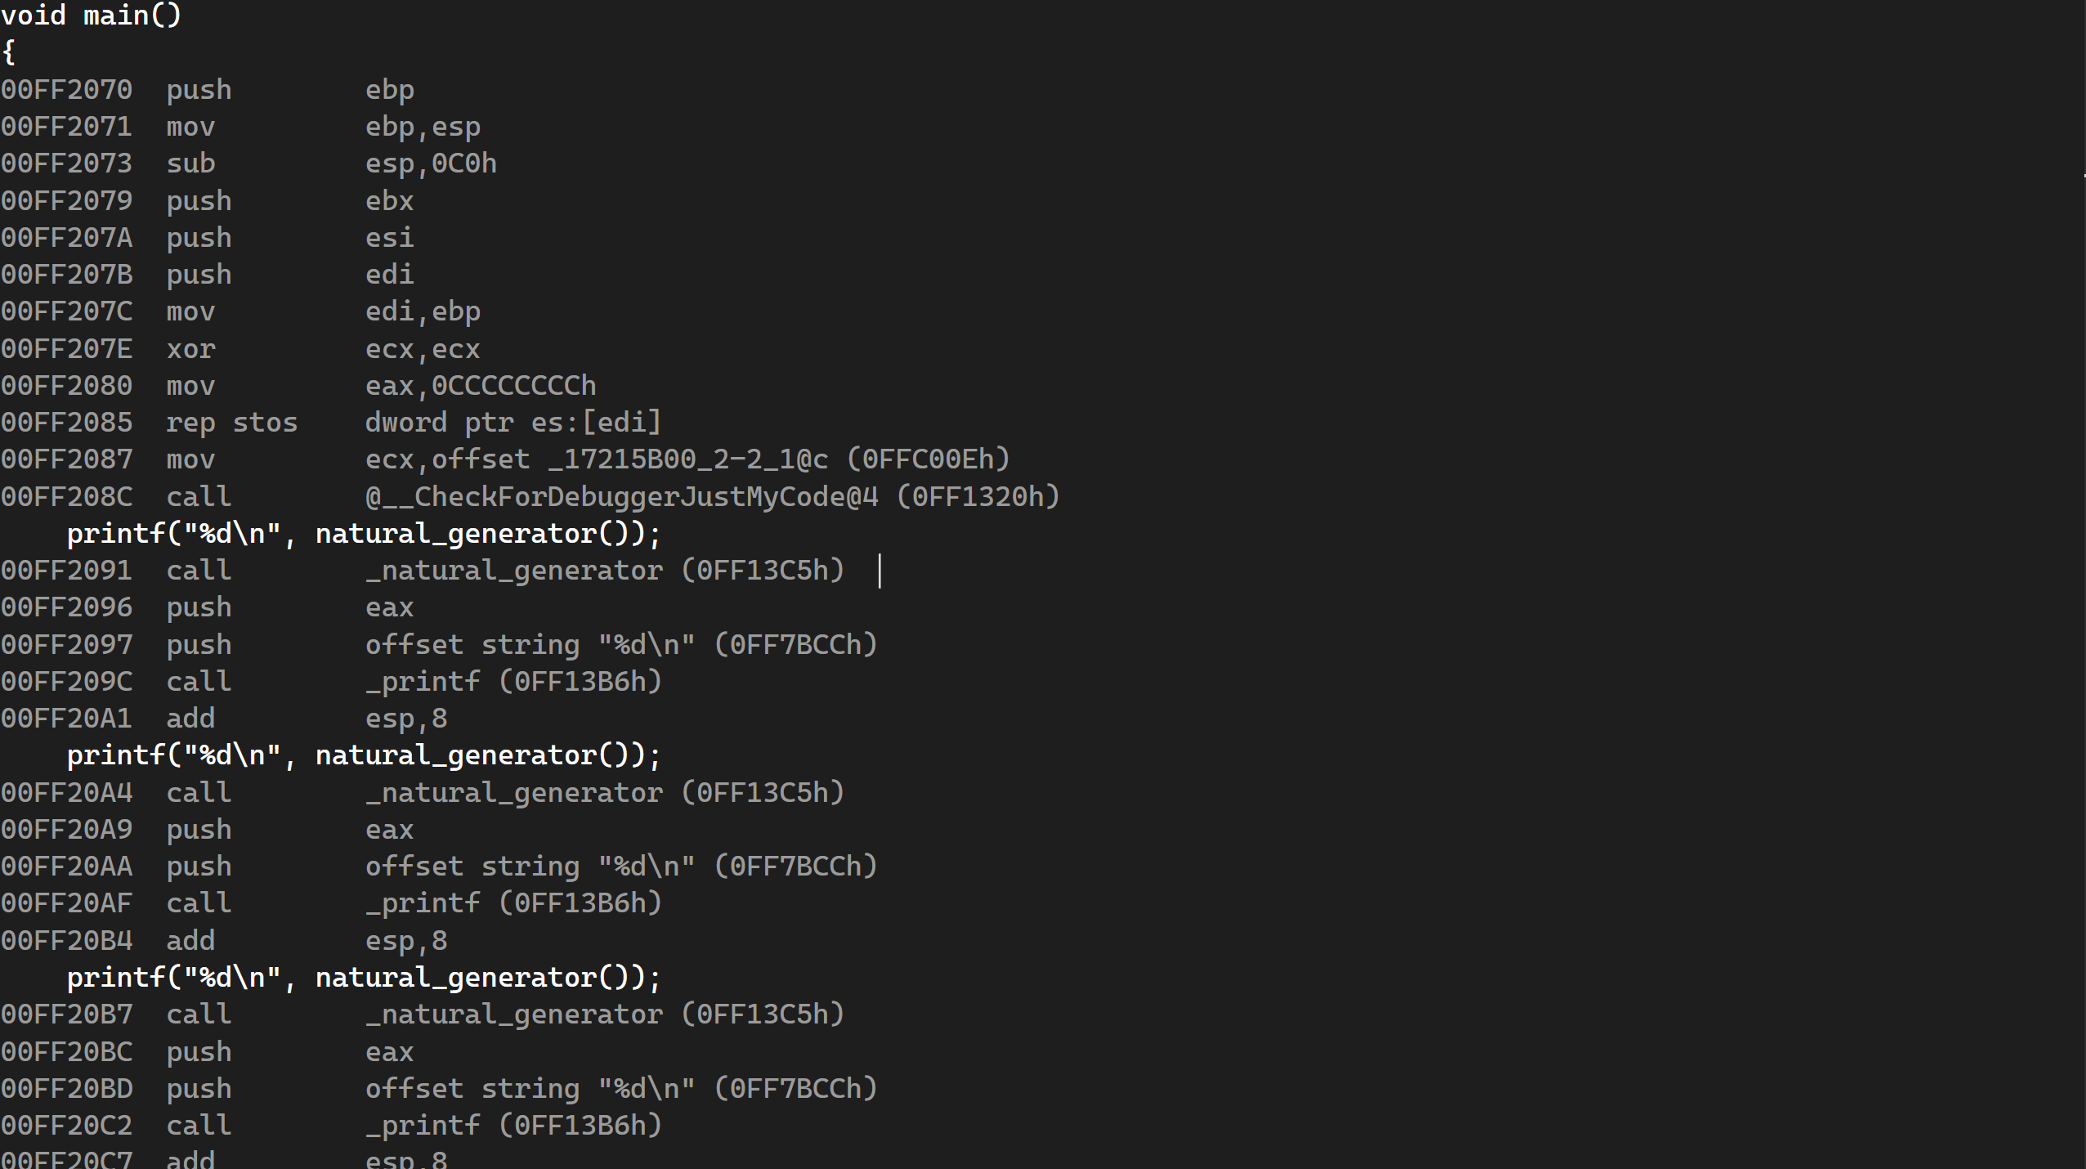

Figure 59. natural_generator.c disassembly pt 1

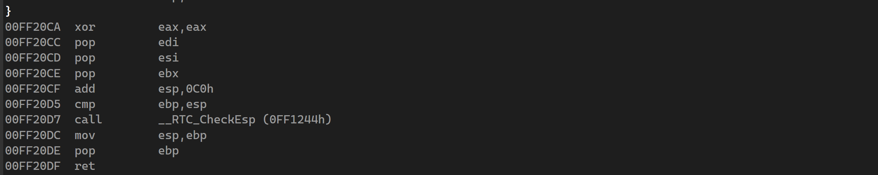

Figure 60. natural_generator.c disassembly pt 2



Figure 61. register for natural_generator.c

## While.c

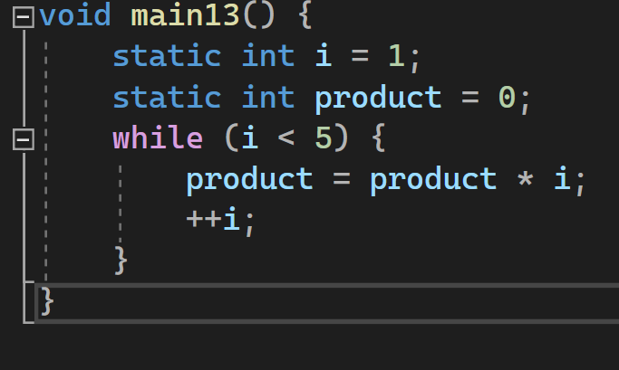

Figure 62. while.c code

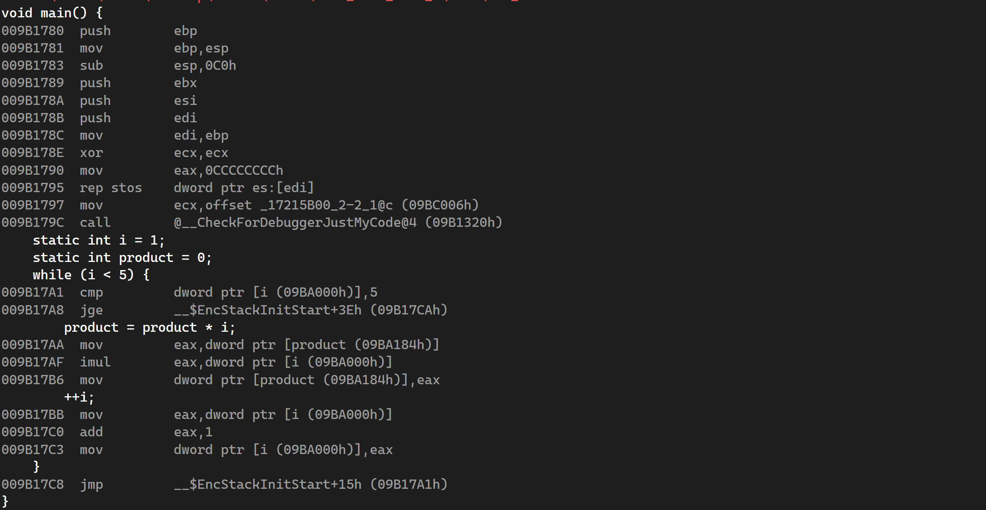

Figure 63. while.c disassembly pt 1

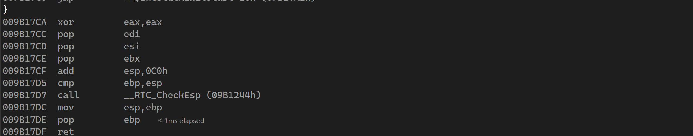

Figure 64. while.c disassembly pt 2

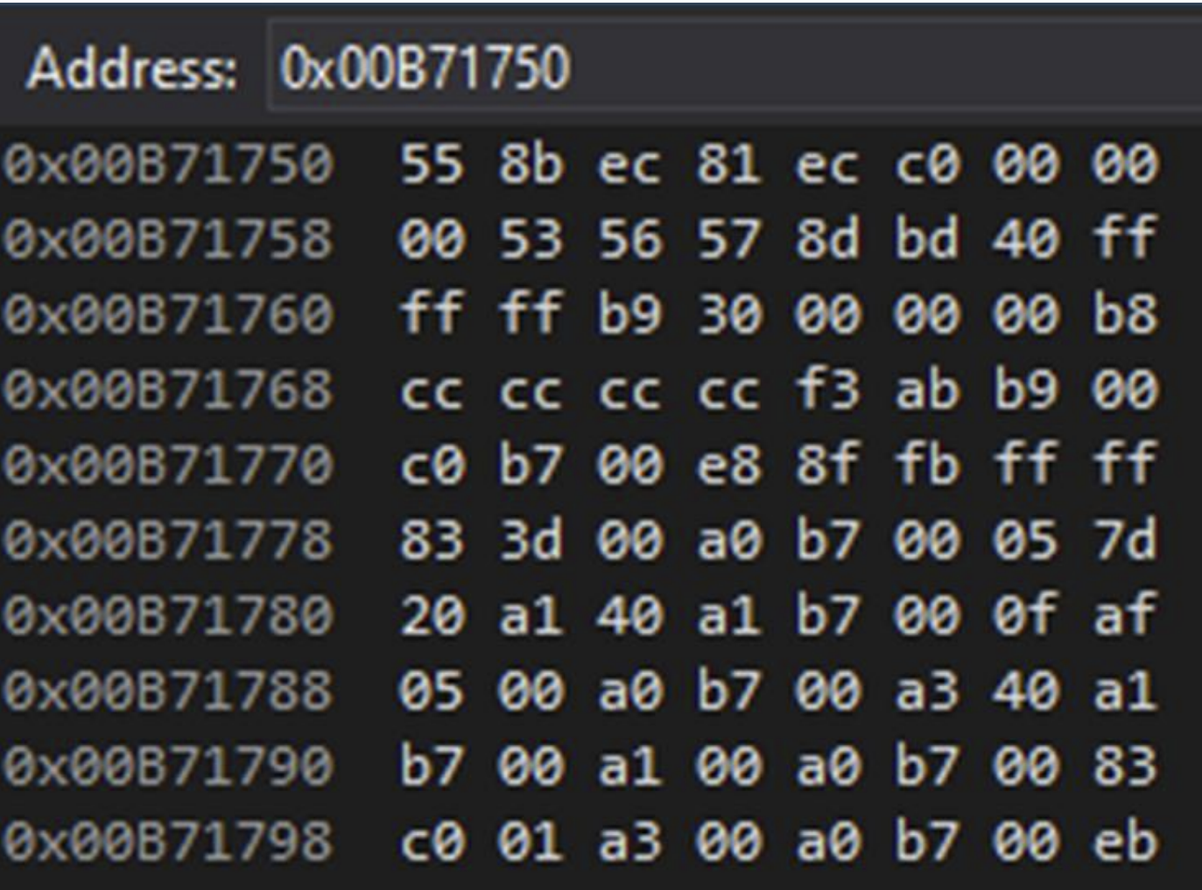

Figure 65. while.c memory



Figure 66. Example of registers.

## For.c

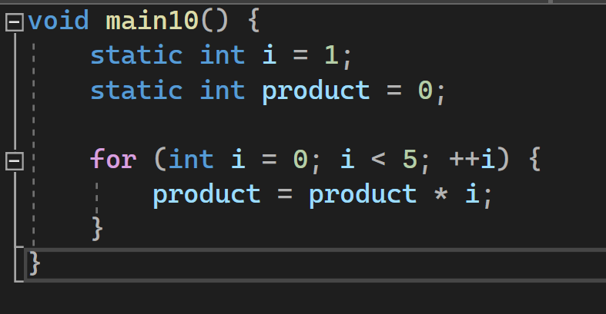

Figure 67. for.c code

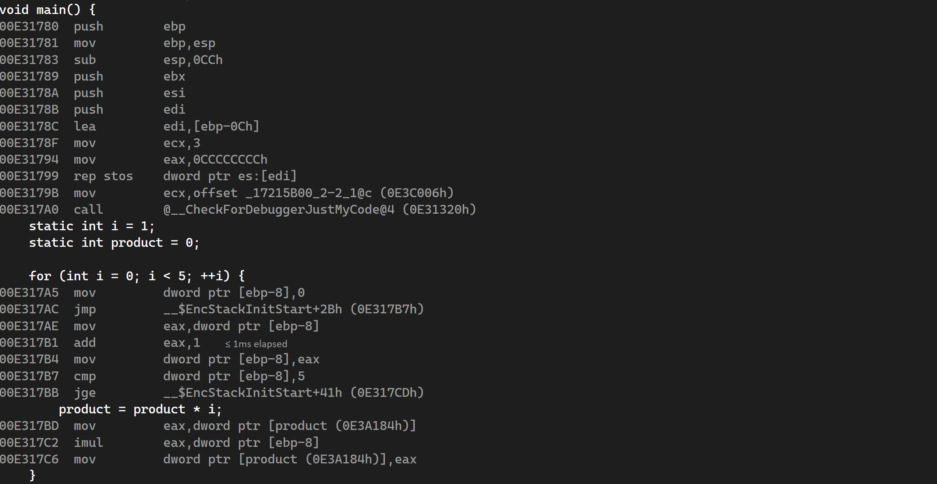

Figure 68. for.c disassembly pt 1

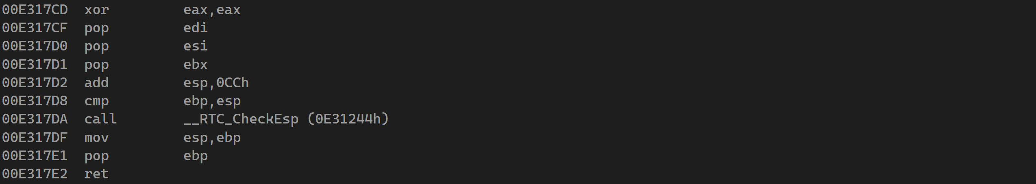

Figure 69. for.c disassembly pt 2



Figure 70. register example for this code

## Myadd.c

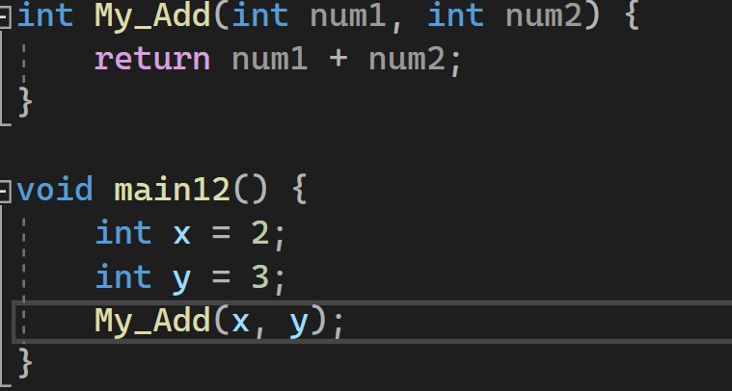

Figure 71. myadd.c code

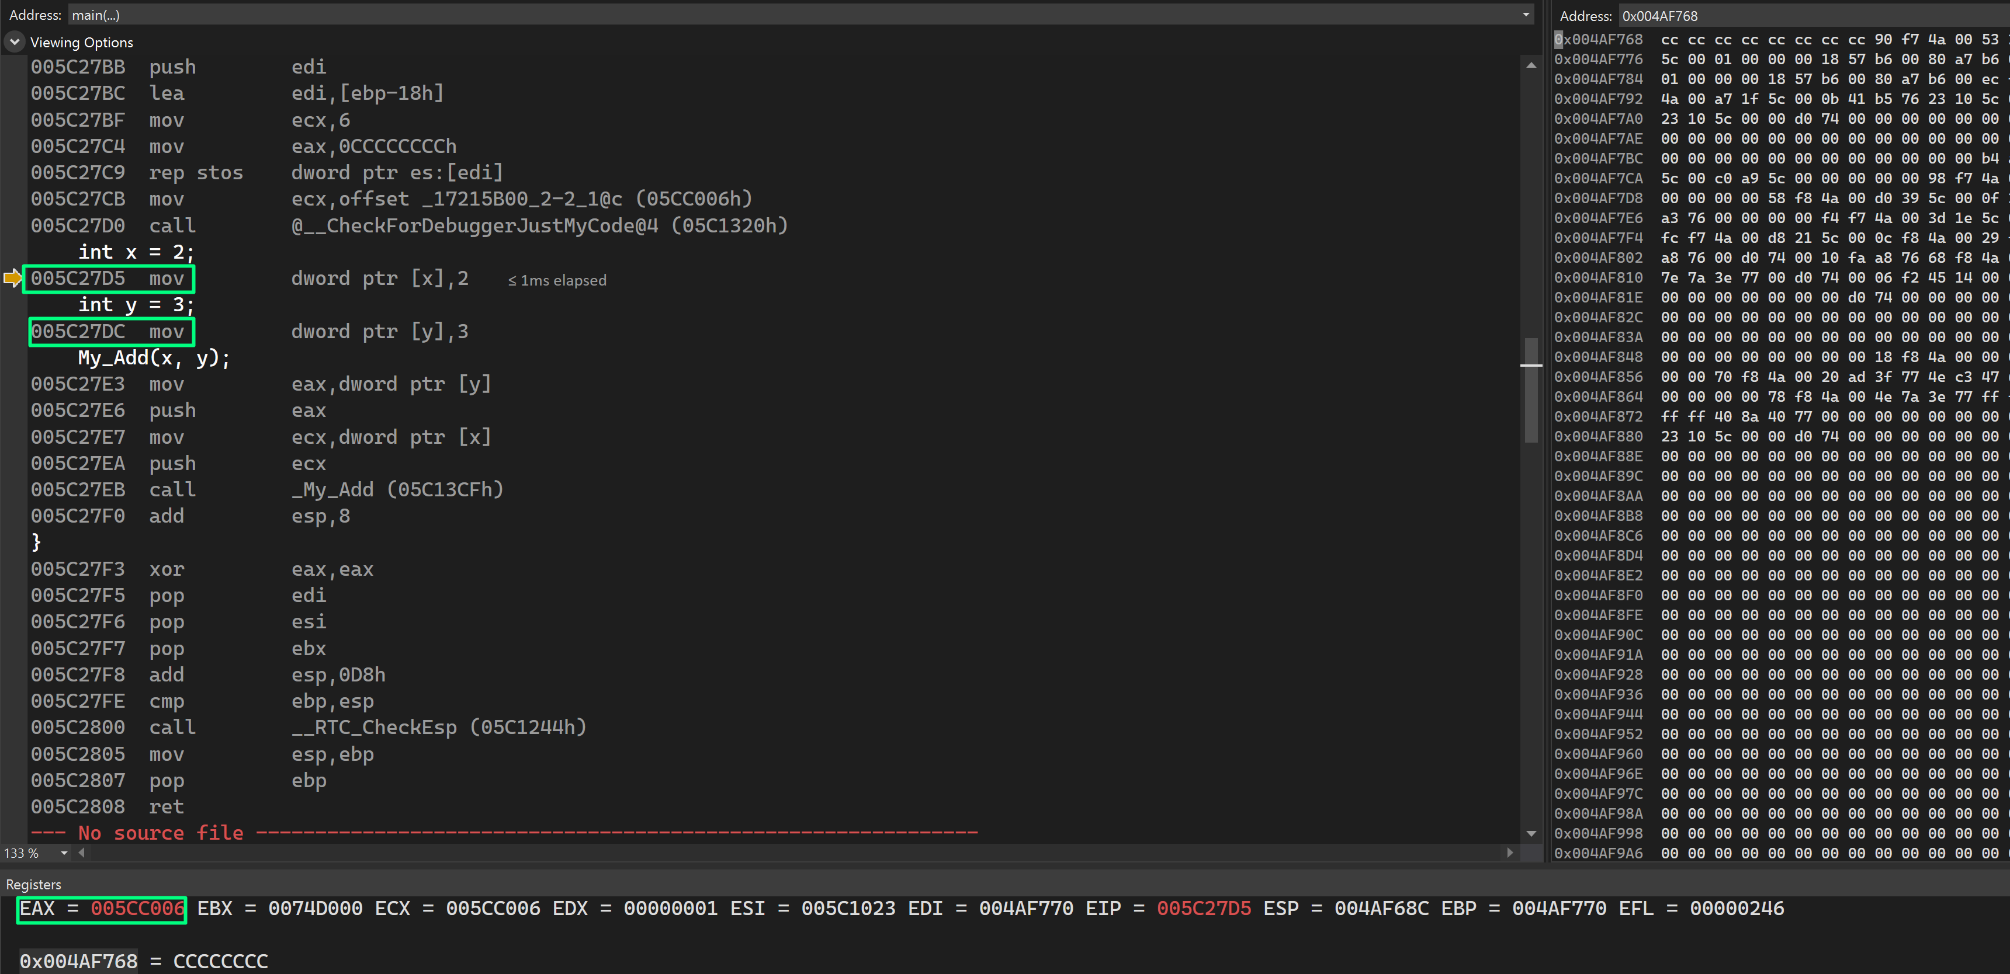

Figure 72. disassembly where mov is moving the integers to location.

# Part 3: Intel x86_64 ISA, Linux 64bit (GDB)

The images below for Part 3 show the identical C code from Part 2 in GDB, as well as its disassembly, memory, and registers. I'll go over the components of a disassembly, memory, and registers windows using 2-2 1.c as an example, but I'll go over the parts of a disassembly, memory, and registers windows separately.

## 2-2_1.c

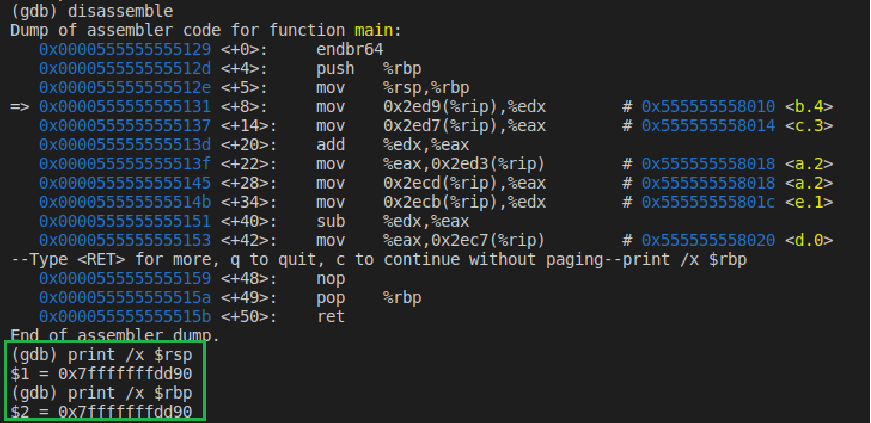

Figure 73. RSP and RBP pointers

The address of the base point is put into the stack, and the address of the $rsp is copied into $rbp.

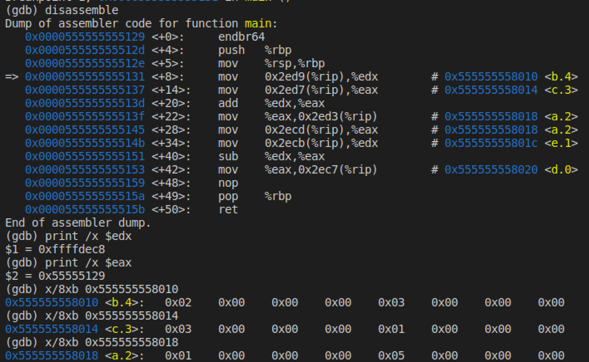

Figure 74. add operation on b+c and result stored in a.

From figure above, we see that register %edx has the value 2 for variable b. Variable be is stored at the address location of 0x555555558010 and variable c is located at address location 0x55555558014 and those values are stored in the registers %edx and %eax, respectively. The add instruction is then executed and the contents of registers %edx and %eax are added together and the result is stored in %eax. We then move the result into the address location where a is stored. The address location is 0x555555558018. From the figure we see where each variable is stored in memory.

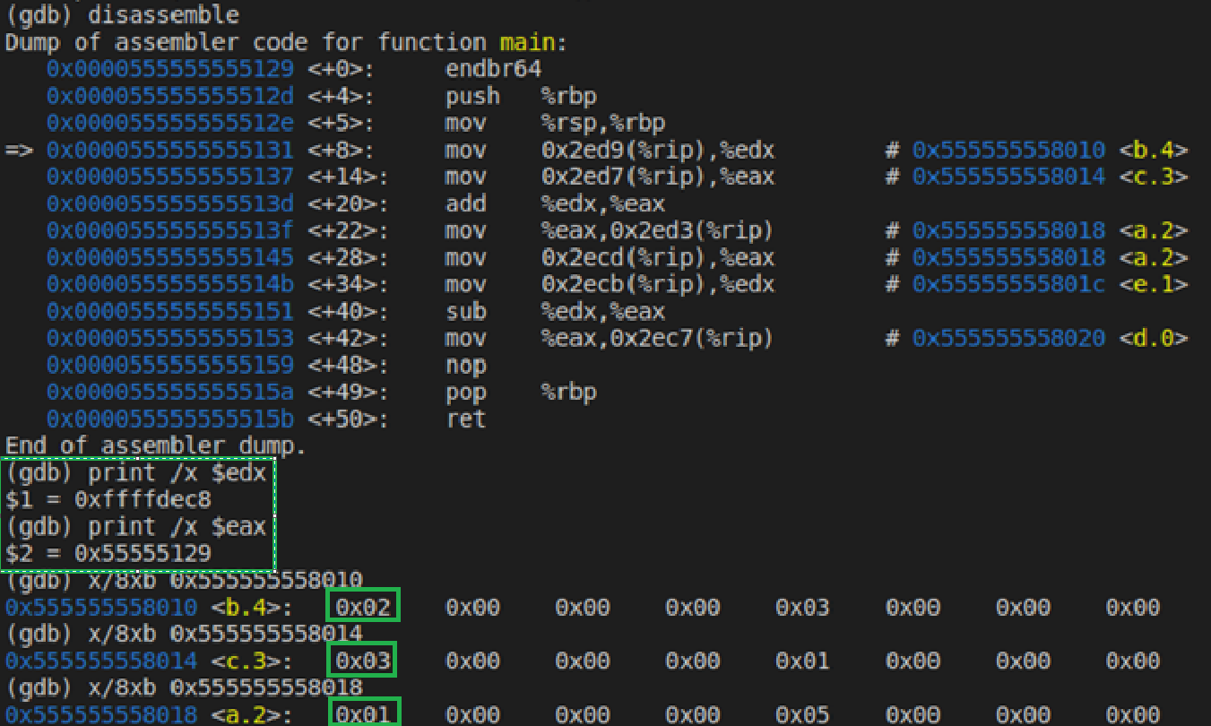

Figure 75. subtraction operation on a-e and stored in d

From figure above, we see that variable a and e both are obtained from their respective location in memory and added moved into registers %eax and %edx respectively. Then we perform the subtraction operation here but note that the subtraction operation doesn’t occur until the arrow on the disassembly code is all the way at the end where the result is loved back into the memory where variable d is stored.

## 2-2_2.c

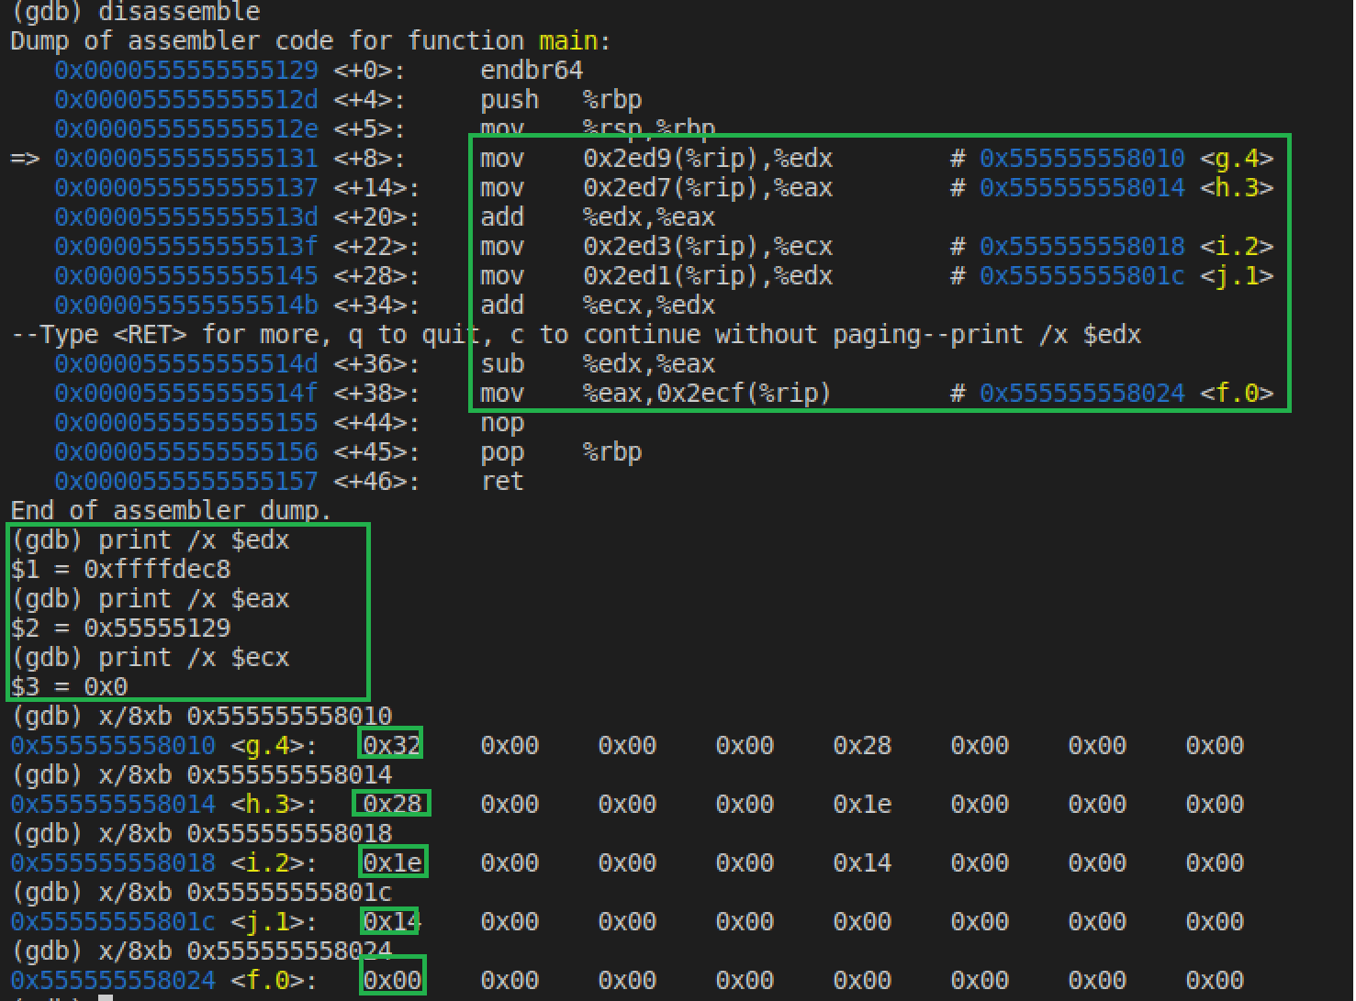

Figure 76. disassemble code of 2-2_2.c

The values of each variable are taken from memory and saved in the registers, as shown in the diagram above. To begin, we can see that g+h is being added, with the values of g and h being grabbed from their respective memory locations and moved to the percent edx and percent eax registers. The result is kept in register percent eax once these registers are added together. After that, the i+j add operation is executed. The values of I and j are taken from memory, put in the appropriate registers, and then added together, as previously. Finally, the result of the two registers, %edx and %eax are subtracted together to get the final answer that is stored in the %eax register and that value is then stored in the memory location of f, which is 0x555555524. We can see in the figure that the value has been stored in the location of variable f.

## 2-3_1

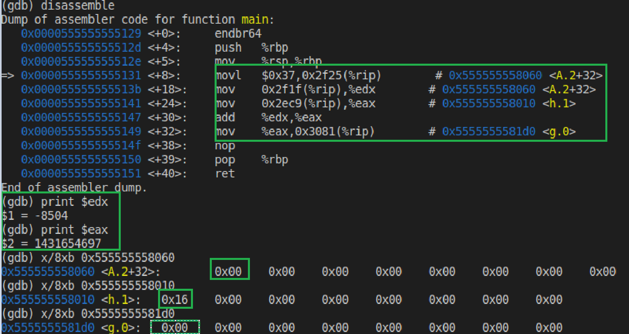

Figure 77. disassembly for 2-3_1.c

From figure above, we can see that we movl the value into the offset from the base address of array A. The value is stored in the array in the array at the address 0x555555558060. We can also see from the figure that value is loaded from memory into register %edx and the value h is loaded from address 0x555555558010 into the register %eax. These registers now have the value stored in h and they are added and the result is stored in register %eax. The result is then stored in memory where variable g is stored.

## 2-3_2.c

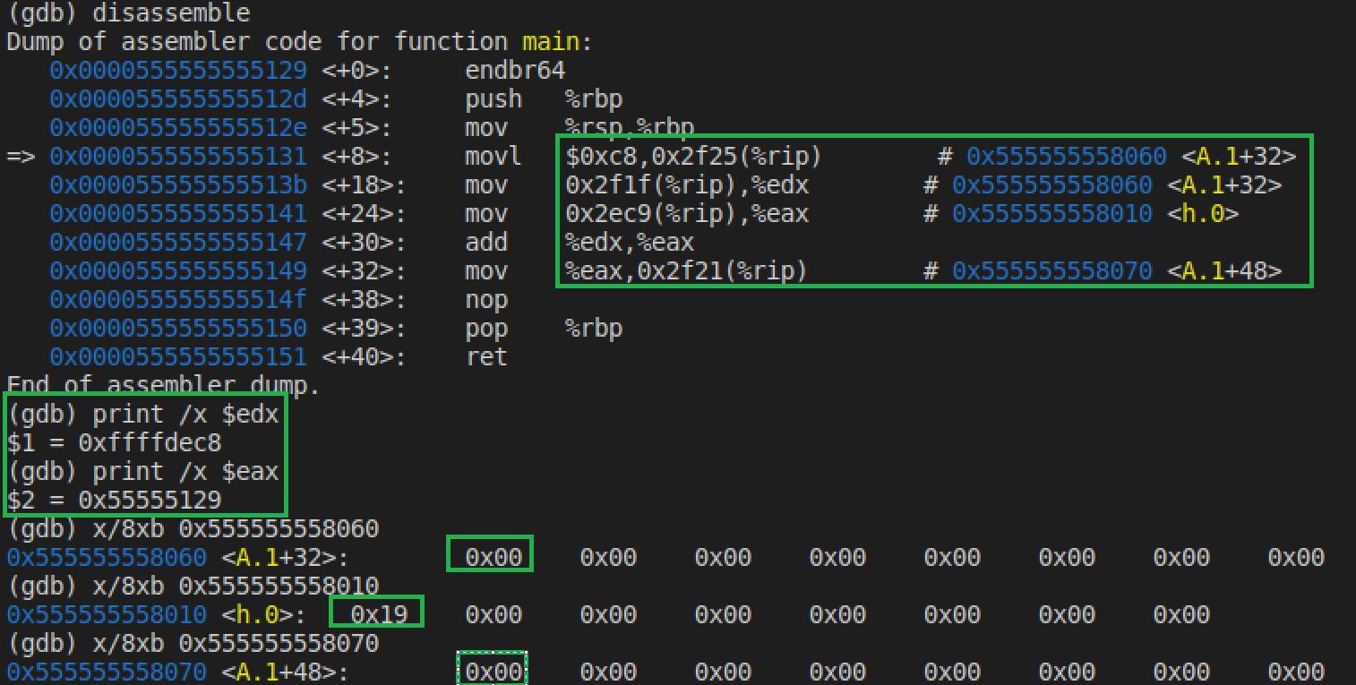

Figure 78. disassemble of 2-3_2.c

As seen in the diagram above, we store the value in memory with an offset from the array A's base address. This also signifies that we're adding as the array's eighth element. We then load that value into register percent edx from the array, as well as the value of h from address 0x555555558010 from register percent eax. The result of adding the two registers is kept in register percent eax. After that, the value in register percent eax is put in array A with an offset from the array's base address. This also means that we are adding the result to the 12 elements of the array A at the address of 0x55555555070. We see all these values stored in memory.

## 2-5_1.c

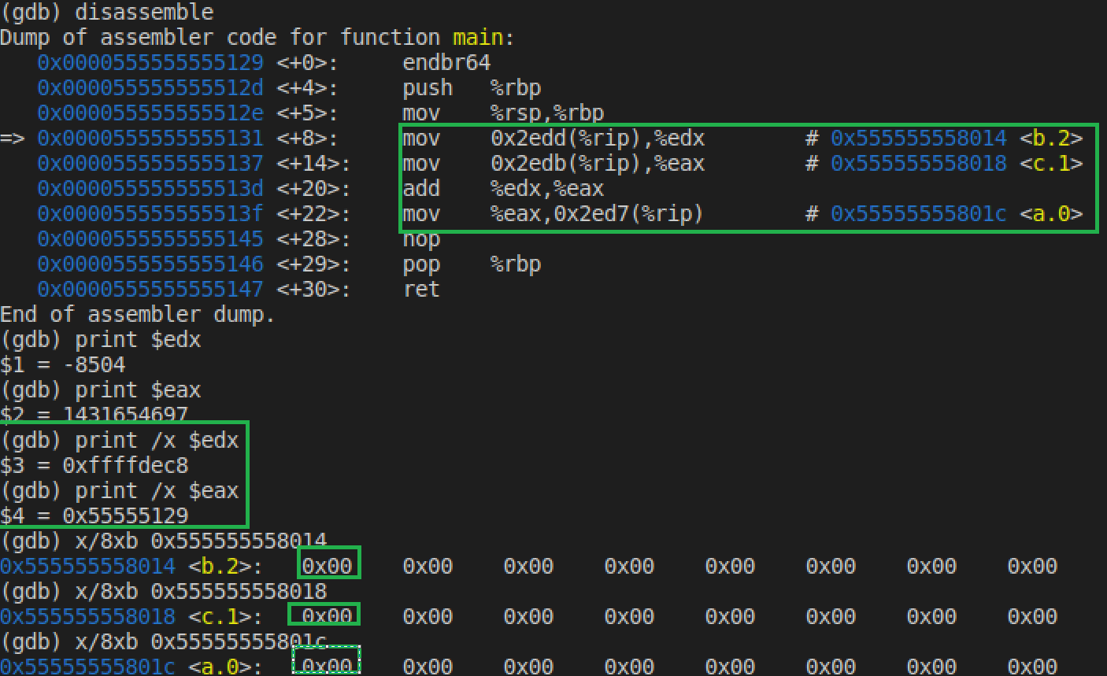

Figure 79. disassemble of 2-5_1.c

## 2-6_1.c

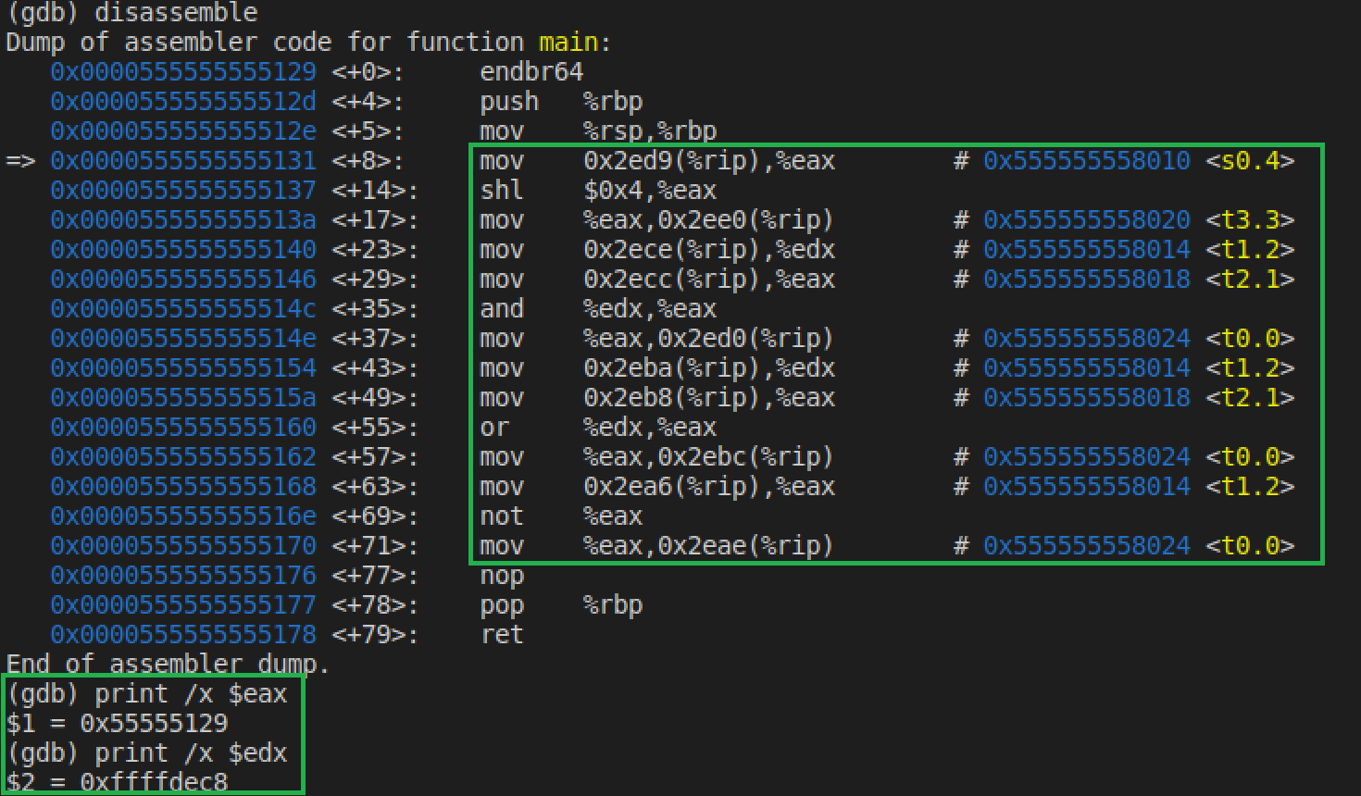

Figure 80. disassemble of 2-6_1.c pt 1

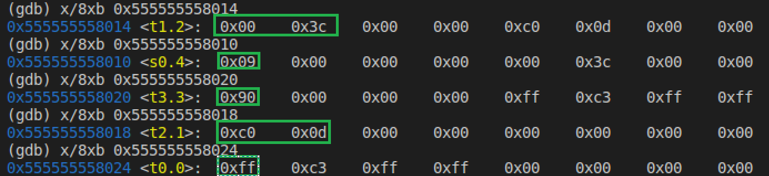

Figure 81. disassemble of 2-6_1.c pt 2

## Natural_generator.c

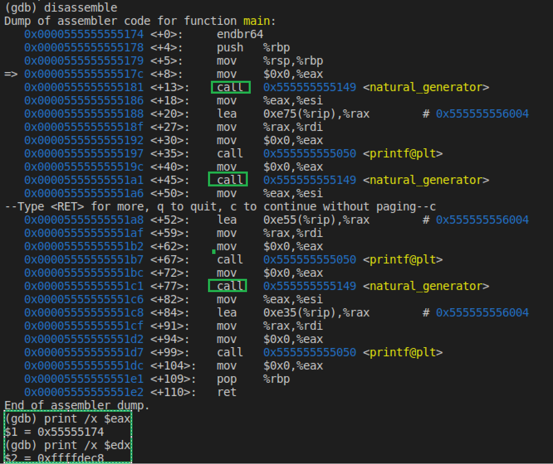

Figure 82. disassemble of natural_generator.c

You can see in figure above that print is visible and call instruction being used. This instruction calling the function natural generator and then storing the address of the new generated value.

## Myadd.c

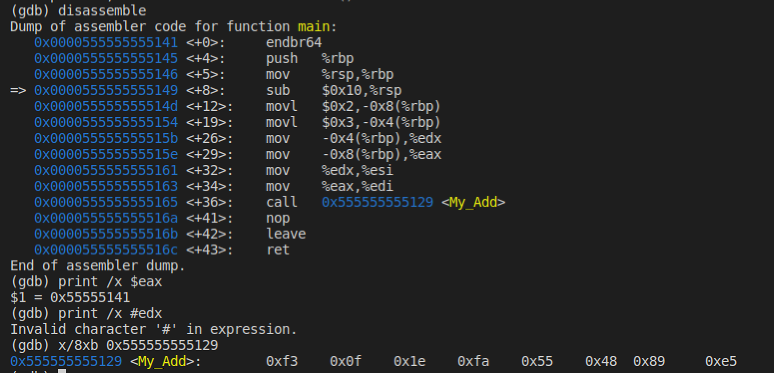

Figure 83. myadd.c disassemble

Jle: conditional jump. It will come to this point check the condition and the bit size that is saved then move to the label that was assigned If the condition is true.

Lea: allows us to obtain the address after certain instructions are done.

Jmp: unconditional jump – it will come to this point and change the pointer registers and instructions to execute will change no matter what. This changes flow of instruction to another point.

Cmp: This compares two operands by basically subtracting it. If the subtraction is positive it returns a 0 and if it is negative it returns a 1. This is different from different assembly languages.

## For.c

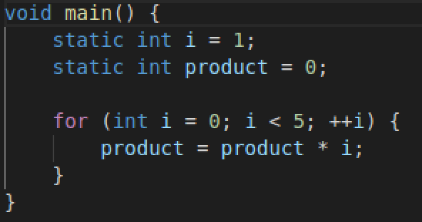

Figure 84. for.c code

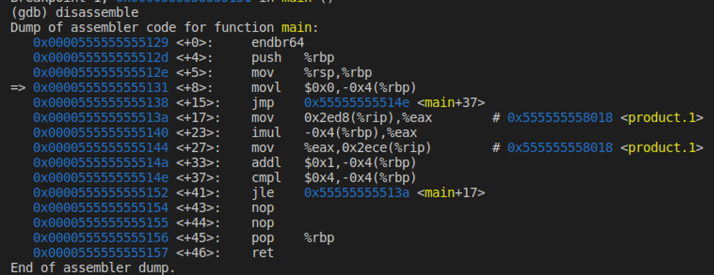

Figure 85. for.c disassemble

## If.c

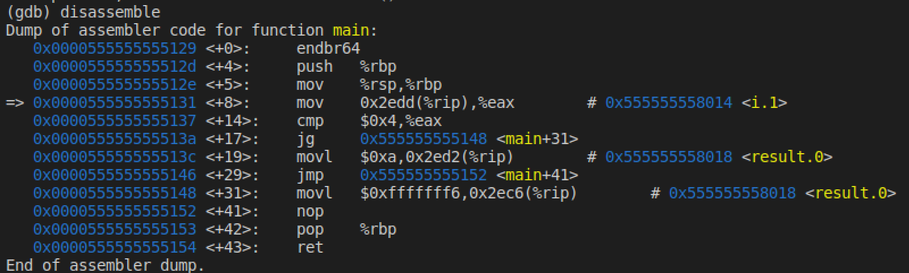

Figure 86. if.c disassemble

## While.c

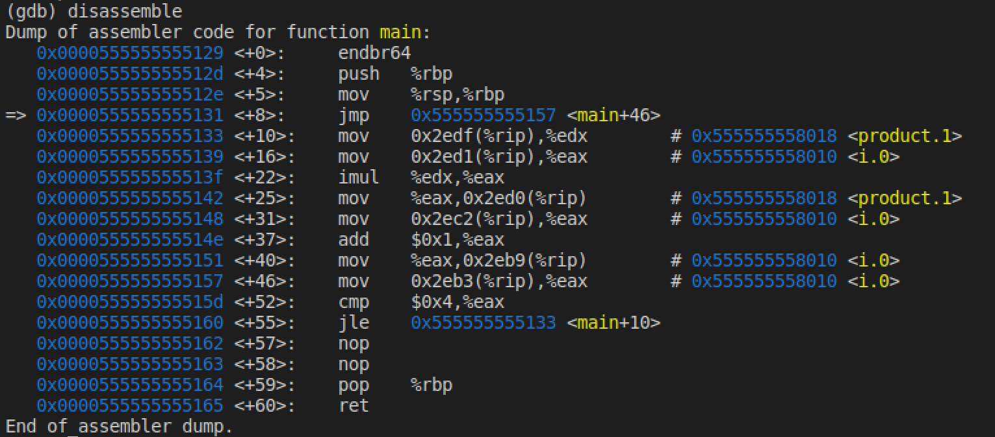

Figure 87. while.c disassemble

# Comparison:

## Mips:

The MIPS MARS simulator is a 32-bit processor, and all of its instructions are 32 bits long. The length of the instructions remains constant throughout the duration of the program. Registers on the MIPS processor include zero, stack pointer, frame pointer, program counter, and so on. Because it points to the top of the stack in our register, the stack pointer is arguably the most critical to comprehend. The frame pointer is pointing to the stack's bottom. Data is stored in Big Endian notation in the simulator. This essentially indicates that we can read data from left to right and that the highest byte is stored at the lowest memory address. The arithmetic the register to hold input, input one, and input two in the MARS MIPS simulator. You can store and, nor, or, and other logical bitwise operations in the logical register. The instructions "lw" and "sw," which stand for load word and store word, are used to communicate data between registers and memory. The load word copies data from memory to a register, whereas the store word copies data from the register back to memory. MIPS uses bne (branch not equal) instructions to build loop statements. The instruction decoder will jump to the designated label if the two operands are not equal. In MIPS, "jal" is used to invoke functions. This saves a return address for the registers to use when specific calls have been completed. The storage of variables in a MIPS processor is determined by the type of variables. Static variables are stored outside of the stack in memory and accessible via an offset from a base address, whereas local variables are stored on the stack and accessed via an offset from the stack pointer. Before the program begins to run, static variables are set. During runtime, local variables are initialized, and the software stores the coded values in a register.

## Intel x32:

We used Visual Studios on Windows to analyze the disassembly for Intel using a 32-bit compiler and debugger. Intel's instruction sets are dynamic and change depending on which instruction is invoked. Small Endian notation is used to store data, which means the least significant byte is put in the lower memory address. Unlike MIPS, Intel simply requires one operand to be in a register, while the second operand can be stored in memory. The instruction "mov" is used to transfer data. Intel uses jne and jmp to create loops. In Intel, function calls are made with the call instruction, which sets the instruction pointer to an instruction that calls a function jump. When the function call is finished, the return address is saved into the stack to be used later. Outside of the stack, static variables are saved in memory. Local variables are assigned stack addresses, and values are loaded directly into memory rather than into a register.

## Linux:

All platforms compare the values within the conditions by moving those values into registers and using comparison-based instructions. All platforms compare the values within the conditions by moving those values into registers and using comparison-based instructions. In and Linux, the while loop iterates by running through the code and having a jump instruction at the end of the iteration. Also whenever, the while loop iterates it has a conditional jump as the first line of the while-scope that is used to break out of the loop if certain conditions are not met. All platforms compare the values within the conditions by moving those values into registers and using comparison-based instructions. In Linux, the for loop iterates by running through the code and having a jump instruction at the end of the iteration. Also, whenever the for-loop iterates, it has a conditional jump that is used to break out of the loop if certain conditions are not met.

# Conclusion:

In this Take Home Test, I discovered that, despite the many architectures, operating systems, and processors, computers in general execute lines of code in a similar fashion. Furthermore, several instructions are performed during the execution of a program, and each architecture has its own style of ordering these statements. Registers and RAM are used by MIPS, Windows 32-bit Intel x86, and Linux Intel x86 with gcc/gdb. However, one significant difference between them is that Intel uses pointers instead of addresses in memory. In a similar vein, they all interact with stack pointers and registers in their own unique ways. In general, each of these architectures has taught me a great deal about how computers interpret instructions and how they are executed.